**DEVELOPMENT OF WEB-BASED MATERNITY CLINIC MANAGEMENT SYSTEM FOR JEWEL’S FIRST MATERNITY LYING-IN AND MEDICAL CLINIC**

**MELITON DIEGO G. LAZARO**

**JOHN ROBERT C. CAPISTRANO**

**CIARRA ROXANNE G. GONZALES**

**A Thesis Presented to the  
Faculty of the College of Science  
Technological University of the Philippines  
Ayala Blvd., Ermita Manila**

**In Partial Fulfillment of the   
Requirement for the Degree  
Bachelor of Science in Information System**

MARCH 2018

**Technological University of the Philippines  
College of Science  
Mathematics Department**

**APPROVAL SHEET**

The thesis hereto entitled:

**DEVELOPMENT OF WEB-BASED MATERNITY CLINIC MANAGEMENT FOR JEWEL’S FIRST MATERNITY LYING-IN AND MEDICAL CLINIC**

prepared and submitted by **MELITON DIEGO G. LAZARO, CIARRA ROXANNE G. GONZALES,** and **JOHN ROBERT C. CAPISTRANO** in partial fulfillment of the requirements for the degree Bachelor of Science in Information System has been examined and is recommended for acceptance and approval for ORAL EXAMINATION.

**DARWIN C. VARGAS**

Adviser

Approved by the Committee on Oral Examination with a grade of **PASSED** on February 27, 2018.

**MAY M. GARCIA PERAGRINO B. AMADOR JR.** Member Member

Accepted in partial fulfillment of the requirement for the degree **Bachelor of Science in Information System.**

____________________ **Prof. Fidela Q. Arañes** Date OIC - Dean

**ACKNOWLEDGEMENT**

First of all, we would like to thank God for all His blessings, the strength and wisdom that He gave through the study.

We would like also to thank our family for the never-ending support that we received.

Special thanks to Prof. Darwin C. Vargas, and Prof. May M. Garcia for the constructive criticisms and advices. We would also like to give our deepest appreciation to the management of Jewel’s First Maternity Lying-in and Medical Clinic for providing us the information that we needed in order to conduct this study.

We would also like to give thanks to Gonzales family for the accommodation and providing our needs.

We are forever grateful to the individuals who helped us throughout this study.

* Authors

**ABSTRACT**

**The study developed a maternity clinic management system for Jewel’s First Maternity Lying-in and Medical Clinic. The objective of the study is to develop a Maternity Clinic Management System with the following attributes: (a) Patient record management system; (b) Patient monitoring system; (c) Online appointment; (d) Report generator for medical records, prenatal and postnatal checkup results, and summary of maternity case. The system was created using the following tools: (a) WAMP (Windows, Apache HTTP Server, MySQL, and PHP: Hypertext Preprocessor); (b) Bootstrap; (c) HTML (Hypertext Markup Language); (d) CSS (Cascading Style Sheet); (e) Sublime Text; (f) Adobe Photoshop CS6. The system was evaluated using ISO 25010 with the following criteria: (a) Functional Suitability; (b) Performance Efficiency; (c) Compatibility; (d) Usability; (e) Reliability; (f) Security; (g) Maintainability; and (h) Portability. The respondents were composed of 45 students from the College of Science – Technological University of the Philippines (TUP) Manila. The result of evaluation is “Very Acceptable”.**

**TABLE OF CONTENTS**

|  |  |
| --- | --- |
|  | **Page** |
| Title Page | 1 |
| Approval Sheet | 2 |
| Acknowledgement | 3 |
| Abstract | 4 |
| Table of Contents | 5 |
| List of Tables | 7 |
| List of Figures | 8 |
| List of Appendices | 10 |
| **Chapter 1 THE PROBLEM AND ITS SETTING** |  |
| Introduction | 11 |
| Background of the Study | 12 |
| Objectives of the Study | 15 |
| Scope and Limitations of the Study | 15 |
| **Chapter 2 CONCEPTUAL FRAMEWORK** |  |
| Review of Related Literature | 17 |
| Related Studies | 33 |
| Conceptual Model of the Study | 35 |
| Operational Definition of Terms | 38 |
| **Chapter 3 METHODOLOGY** |  |
| Project Design | 39 |
| Project Development | 46 |
| Operation and Testing Procedure | 50 |
| Evaluation Procedure | 52 |
| **Chapter 4 RESULTS AND DISCUSSION** |  |
| Project Description | 55 |
| Project Structure | 56 |
| Project Capabilities and Limitations | 70 |
| Project Evaluation | 71 |
| **Chapter 5 SUMMARY OF FINDINGS, CONCLUSIONS, AND**  **RECOMMENDATIONS** |  |
| Summary of Findings | 79 |
| Conclusions | 80 |
| Recommendations | 81 |
|  |  |
|  |
| **REFERENCES** | 91 |
|  |
| **CURRICULUM VITAE** | 92 |

**LIST OF TABLES**

|  |  |  |
| --- | --- | --- |
| **Table** | **Name** | **Page** |
| 1 | Functionality Test | 50 |
| 2 | Rating Scale for Evaluation Instrument | 53 |
| 3 | Numerical Range and its Qualitative Interpretation | 54 |
| 4 | Functional Suitability Evaluation Result | 71 |
| 5 | Performance Efficiency Evaluation Result | 72 |
| 6 | Compatibility Evaluation Result | 72 |
| 7 | Usability Evaluation Result | 73 |
| 8 | Reliability Evaluation Result | 73 |
| 9 | Security Evaluation Result | 75 |
| 10 | Maintainability Evaluation Result | 76 |
| 11 | Portability Evaluation Result | 77 |
| 12 | Overall Percentage Frequency of Evaluation Result | 78 |

**LIST OF FIGURES**

|  |  |  |
| --- | --- | --- |
| **Figure** | **Name** | **Page** |
| 1 | Conceptual Model of the Study | 35 |
| 2 | Context Level Diagram | 39 |
| 3 | Top-level DFD (Prenatal checkup process) | 40 |
| 4 | Top-level DFD (Consultation process) | 41 |
| 5 | Top-level DFD (Postnatal Process) | 42 |
| 6 | Top-level DFD (Childbirth Process) | 43 |
| 7 | Top-level DFD (Laboratory request process) | 44 |
| 8 | Use Case Diagram of the proposed system | 45 |
| 9 | Waterfall Method | 46 |
| 10 | Entity Relationship Diagram of the proposed system | 49 |
| 11 | Statistical Mean Method | 52 |
| 12 | MCMS Homepage | 56 |
| 13 | JFMLMC’s information | 56 |
| 14 | Core Beliefs | 57 |
| 15 | Services Offered | 57 |
| 16 | Online Appointment Panel | 58 |
| 17 | Contact Us Form | 58 |
| 18 | Patient’s Login | 59 |
| 19 | Login Page | 59 |
| 20 | Side Navigation Bar | 60 |
| 21 | Dashboard | 60 |
| 22 | Maternity Case List | 61 |
| 23 | Creating New Maternity Case | 62 |
| 24 | Profiling | 62 |
| 25 | Medical History | 63 |
| 26 | Physical Examination | 63 |
| 27 | Maternity Case Profile | 64 |
| 28 | Maternity Case Timeline | 65 |
| 29 | Childbirth Modal | 65 |
| 30 | Archive Maternity Case Modal | 66 |
| 31 | Patient List | 67 |
| 32 | Patient Profile | 67 |
| 33 | Infant List | 68 |
| 34 | Physical Examination Result | 68 |
| 35 | Medical History Result | 69 |

**LIST OF APPENDICES**

|  |  |  |
| --- | --- | --- |
| **Appendix** | **Name** | **Page** |
| A | Gantt Chart | 82 |
| B | Tabulation Table | 86 |
| C | User Manual | 88 |
| D | References | 91 |

**CHAPTER 1  
  
THE PROBLEM AND ITS SETTING**

This chapter contains the introduction, background of the study, objectives of the study, scope and delimitation, and significance of the study.  
  
**Introduction**

Maternity Clinic, also Lying-in Clinic, is an institution in the Philippines that provide excellent maternal services for pregnant women, newborn infants, and promoting reproductive health for the community. It offers maternal services including prenatal checkup, postnatal checkup, delivery or child birth, consultation, immunization, newborn screening, laboratory, and Family Planning. Maternity Clinic’s organization must be mainly composed of Midwives, Obstetrician, Gynecologist, and Pediatrician. Midwives, Obstetrician, and Gynecologist are responsible mostly to the maternal services for pregnant patients, while the Pediatrician is the one who manage the health of the child.   
  
 Maternity Clinics are under the Department of Health (DOH) and must secure necessary permits to operate. Some Midwives are affiliated to some associations like the Midwives Association of the Philippines (IMAP, Inc.). IMAP, Inc. was born on 1947 headed by Atty. Angelina C. Ponce where its main visions are to promote highest standards of midwifery practice, enhance the competence of members, reduce maternal and infant mortality, and sustain collaboration and partnership with related agencies.

**Background of the Study**

The Jewel’s First Maternity Lying-in and Medical Clinic is located at 136 Block 8 Zone 2 Brgy. Fort Bonifacio, Taguig City. Its second branch is located at 131, Lot 8, Meralco road Upper Bicutan, Taguig City. It’s a private maternity facility that performs clinical and maternal duties to their patients for almost 8 years and founded by Mrs. Remedios A. Saludes, R.M.  
 This maternity clinic is still using the old process of paper system in their recording process. Using papers in recording patient’s information, checkup results, and transaction records, piles of records are stored in their respective filing cabinet. It causes a slow retrieval of files and sometimes misplacement of some records due to overloading of files in the filing cabinet. The process of generating of report, too, takes time because the staff-in-charge needs to retrieve a record and create a report using pen and papers. Patients can only know the availability of their desired appointment when they ask the in-charge midwife about it.

During the duration of pregnancy, a patient is required to undergo Prenatal Checkup to have a healthy pregnancy. In the first trimester, the patient must go through once or twice prenatal checkup. The succeeding five months will have at least three visits for prenatal checkups every month. The ninth month will be every week until the due date of pregnancy. Prenatal Checkup is mainly composed of Physical Examination and Medical History. Physical Examination is firstly done through measuring the height and weight of the patient to calculate the Body Mass Index (BMI). The BMI will determine the prescribed weight gain to be maintained while pregnant. Physical Examination is also consisting of measuring the blood pressure, heart and breathing rate. The midwife will conduct a complete physical evaluation especially in cervix, uterus, and vagina of the patient to have a confirmation about the stage of pregnancy.

On the other hand, Medical History examination is also important to have an assessment about the pregnancy history of the patient. The midwife will interview about the patient’s past pregnancies, if she had undergone childbirth, menstrual cycle, and gynecological history. The said patient will also be examined about her medical history, medications used, and her lifestyle. The patient must be honest and open about this to ensure a healthy pregnancy.

Recording process during the delivery of the patient starts by identifying the date and time of labor and delivery, patient’s information and type of delivery. During this time, the prenatal checkup results of the patient are essential for the midwives to have an early assessment about the maternal care. These checkup results will be the basis for a successful childbirth.

After a successful delivery, the following information of the newborn infant will be now recorded and stored in the filing cabinet. One of this is the Physical Examination to check for obvious signs or status of the newborn infant. After 24 hours, the Newborn Screening (NBS) will also be done to ensure that the infant is safe from Congenital Metabolic Disorder. Without Newborn Screening, an infant with Congenital Metabolic Disorder may lead to mental retardation or death if it is left untreated.

Postnatal Checkup will be scheduled six weeks after the patient’s childbirth. It is also called “Six-week check”. The midwife will make sure that the infant is growing healthy and the mother is recovering well from the operation. Postnatal Checkup is an important evaluation for both patients. It is important for the mother to discuss her physical, mental, and emotional state after the childbirth. It is also a chance for the patient and her partner to talk about to the midwife about the difficulties she experienced during the six weeks and other related things about her post pregnancy. On the other hand, the newborn infant will undergo physical examinations to check if all the organs are developing well. Immunization and vaccines are also included to ensure the health of the patient. Information about the newborn infant will be stored in a baby book which will be used in the following checkups.

The researchers thought the problems in storage of the patients’ record and the generating of reports.

The researchers aimed to develop a Maternity Clinic Management System which is trusted management, retrieval, storage and the creation of reports of the patients’ records.

**Objectives of the Study**

The general objective of the study is to develop a Maternity Clinic Management  
System. Specifically aims to:

1. Design the system with the following attributes:

* patient record management system;
* patient monitoring system;
* online appointment;
* report generator for medical records, prenatal and postnatal checkup results, and summary of maternity case.

1. Create the system using Sublime Text as text editor, WAMP (Windows, Apache,  
    MySQL, and PHP: Hypertext Preprocessor), HTML (Hypertext Markup

Language), CSS (Cascading Style Sheet), and Adobe Photoshop CS6.

1. Test and improve the system in terms of functionality and usability.
2. Determine the level of acceptability of the developed system using ISO 25010.

**Scope and Limitations of the Study**

The study focused on the development of Maternity Clinic Management System for Jewel’s First Maternity Lying-in and Medical Clinic.The administrator can modify and register patient records. The admin can also view and print report of patient medical history and its statement of account. Patients can view her profile and set an appointment online.

Laboratory result, recording labor information of patients, and centralizing the database of two clinic branches are not included in the system.

**CHAPTER 2  
CONCEPTUAL FRAMEWORK**

This chapter presents the review of related literature and review of related studies. It also includes the conceptual model of the study and the operational definition of terms.  
**Review of Related Literature**

***Records Management System***

According to techopedia.com, a Record Management System is the management of records for an organization throughout the records-life cycle. The activities in this management include the systematic and efficient control of the creation, maintenance, and destruction of the records along with the business transactions associated with them.

Techopedia also explains the activities involved in records management. These are identifying first the information that is needed to be captured; this follows up the information planning and enforcement of policies and practices regarding creation, maintenance, and disposal of records. Next is the classification, identification, and storing the records. The last activity mentioned is the coordination of providing internal and external access to the records without forfeiting the data privacy and business and data confidentiality of the organization.

Furthermore, ricohdocs.com explained that the records management is basically the process of creating, maintaining, using, and disposing records in an organized way. This helps achieve transparent, accountable, and efficient governance. The records should be managed following the records management program of an organization that is governed by a certain policy.  
 In addition to this, wikipedia.org clarifies that the ISO 15489-1: 2001 standard (“ISO 15489-1: 2001”) defines record management as “the field of management responsible for the efficient and systematic control of the creation, receipt, maintenance, use and disposition of records, including the processes for capturing and maintaining evidence and information about business activities and transaction in the form of records.” ***Maternity Clinic***

Wikipedia.org defines the maternity clinic as a clinic that specializes in maternal care. It is responsible of caring for women during and after pregnancy. It also provides care for newborn infants, facilities for childbirth, maternity checkups, and family planning. It may also act as centers for clinical training in midwifery and obstetrics.

A place where you can do regular check-ups that allow doctors and midwives to treat and prevent potential health issues throughout the way of the pregnancy while giving advice for healthy lifestyle that can give advantage both mother and child.

***Midwifery***

According to Wikipedia.org, Midwifery, as known as obstetrics, is a health science and health profession that deals with pregnancy, childbirth, newborn care, reproductive health and postpartum period.

Additionally, World Health Organization explains that midwifery encompasses care for women during pregnancy, labor, and until the postpartum period. It is also stated in who.int, World Health Organization’s website, that midwifery is also bound to newborn care. The main objectives are to prevent health problems in pregnancy, detection of abnormal conditions of both patients, and providing medical assistance when required.

Midwifery in the Philippines as a profession was relatively unknown until Dr. Jose Fabella founded the first school of midwifery in May 1992 – the Maternity and Children’s Hospital (now called Dr. Jose Fabella Memorial Hospital). According to the Integrated Midwives’ Association of the Philippines (IMAP, Inc.), Dr. Fabella led the midwifery to utilize in the Philippines by training the young women in midwifery to gradually supplant the unlicensed midwives. Midwifery became a course and continuously expanding in the country. Thereafter, the midwifery profession has reached a high standard and its activities have increased in a scope. This result into recognition that a dynamic midwives’ association must be created to serve, train, educate, and provide health service in the country. Integrated Midwives Association of the Philippines was created through this recognition on March 17, 1976.

***WAMP***

WAMP is an acronym for Windows, Apache, MySQL, and PHP. According to their website, wampserver.com, WAMPServer is a Windows web development environment. It allows the user to create web application with Apache2, PHP, and MySQL database. PhpMyAdmin is also included to manage the database easily.

***Windows Operating System*** An article written by The Editors of Encyclopedia Britannica in britannica.com discussed the Windows OS. Windows was created by Microsoft Corporation to run on Personal Computers (PC). It features the first Graphical User Interface (GUI) for IBM-compatible PCs. Through the years since 1985, Microsoft’s Windows dominated in the market and approximately 90 percent of PCs run a version of Windows. Up until today, Windows expands its product creating more possibilities and innovation to its customers.

***Apache HTTP Server***

According to their website, httpd.apache.org, Apache HTTP Server is free and open-source cross-platform web server software. It aimed at creating a robust, commercial-grade, full of feature, and freely-available source code implementation of an HTTP (Web) Server.

An article in Wikepedia.org stating that Apache HTTP Server is free and open-source cross-platform web server software, released under the terms of Apache License 2.0. It is developed and maintained by an open community of developers under the auspices of the Apache Software Foundation.

***PHP***  
 An article in Wikipedia.org about scripting language discusses about PHP. PHP is a server-side scripting language that is designed primarily for web development; PHP also extends its usability in general-purpose programming language. It is originally created by Rasmus Lerdorf in 1994 and it stands for the recursive acronym for PHP: Hypertext Preprocessor. An addition from the article, a PHP code may be embedded into HTML or HTML5 markup, web frameworks, web content management systems, and web template systems.

According to techterms.com, PHP is an HTML-embedded Web scripting language. It means that PHP code can be inserted into the HTML of a Web page. When a PHP page is accessed, the PHP code is read or “parsed” by the server. Additionally, the output from the PHP functions on the page are typically returned as HTML code, which can be read by the browser.

***MySQL***

According to techtarget.com, MySQL is an open-source relational database management system. It is created by a Swedish company named MySQL AB and founded by David Axmark, Allan Larsson and Michael “Monty” Widenius. MySQL’s name is a combination from Michael Widenius’ daughter “My”, and the abbreviation for Structured Query Language, “SQL”. MySQL’s first internal release was on May 23, 1995 and a Windows version was released on January 8, 1998. Continuous versions were released every year and in 2008, Sun Microsystems acquired MySQL AB. Shortly after 2 years, Oracle Corporation acquired Sun Microsystems in January 27, 2010.

Additionally, an article from Wikepedia.org discusses that MySQL is an open-source relational database management system. Furthermore, MySQL is written in C and C++.

***Cascading Style Sheet***

As stated in www.w3.org, CSS is responsible on insulating the script body to its display. This is specially made to give the author/creator a control outside of structure, particularly the text alignment, object position on the page, audio and speech output, font characteristics and tables. In addition, by using style sheets your project can be more accessible than usual.

In expanding the idea to the subject matter, CSS can be your reference by offering some features that can give a precise control on your project such as control on spacing, alignment and positioning. Authors/creators can avoid unexpected use of such tags. Relevance to the subject of issue about tags, the style sheet itself can also avoid and help on reduce image misuse.

Using style sheets can allow you to access the fundamentals of HTML like font size, color and style and also it can support automatically generated numbers, markers and other content that can help the authors to stay oriented within their document.

***Dataflow Diagram***

According to https://www.lucidchart.com/pages/data-flow-diagram, a data flow diagram (DFD) maps out the flow of information for any process or system. It uses defined symbols like rectangles, circles and arrows, plus short text labels, to show data inputs, outputs, storage points and the routes between each destination. Data flowcharts can range from simple, even hand-drawn process overviews, to in-depth, multi-level DFDs that dig progressively deeper into how the data is handled. They can be used to analyze an existing system or model a new one. Like all the best diagrams and charts, a DFD can often visually “say” things that would be hard to explain in words, and they work for both technical and nontechnical audiences, from developer to CEO. That’s why DFDs remain so popular after all these years. While they work well for data flow software and systems, they are less applicable nowadays to visualizing interactive, real-time or database-oriented software or systems.

A data flow diagram can dive into progressively more detail by using levels and layers, zeroing in on a piece.  DFD levels are numbered 0, 1 or 2, and occasionally go to even Level 3 or beyond. The necessary level of detail depends on the scope of what you are trying to accomplish.

* DFD Level 0 is also called a Context Diagram. It’s a basic overview of the whole system or process being analyzed or modeled. It’s designed to be an at-a-glance view, showing the system as a single high-level process, with its relationship to external entities. It should be easily understood by a wide audience, including stakeholders, business analysts, data analysts and developers.
* DFD Level 1 provides a more detailed breakout of pieces of the Context Level Diagram. You will highlight the main functions carried out by the system, as you break down the high-level process of the Context Diagram into its sub processes.
* DFD Level 2 then goes one step deeper into parts of Level 1. It may require more text to reach the necessary level of detail about the system’s functioning.
* Progression to Levels 3, 4 and beyond is possible, but going beyond Level 3 is uncommon. Doing so can create complexity that makes it difficult to communicate, compare or model effectively.

***CodeIgniter***

In a discussion presented by lynda.com, CodeIgniter is defined as an open-source PHP Web Application Framework that has rapid development, provides logical structure and reusable interface. CI also features a lightweight framework, fast performance, and a little configuration.

An article from Wikipedia.org states that CodeIgniter is loosely based on the popular model-view-controller (MVC) development pattern. It can be also modified to use Hierarchical Model View Controller (HMVC) that allows developers to maintain modular grouping of controller, models, and views arranged in a sub-directory format.

***jQuery***

According to technopedia.com, jQuery is a concise and fast JavaScript library that can be used to simplify handling. Techterms.com also defined jQuery as a JavaScript library that allows Web Developer to add extra functionality to their websites.

Additionally, codeproject.com discusses that jQuery is not a language but a well written JavaScript code. It was released on January 2006 at BarCamp New York City by John Resig.

***ISO 25010***

ISO 25010, a product quality model composed of eight characteristics (which are further subdivided into sub characteristics) that relate to static properties of software and dynamic properties of the computer system. The model is applicable to both computer systems and software products.

ISO 25010, a quality in use model composed of eight characteristics (further subdivided into sub characteristics) that relate to the outcome of interaction when a product is used in a particular context. This system model is applicable to the complete human-computer system, including both computer systems in use and software products in use.

ISO 25010 the quality of a system is the degree to which the system satisfies the stated and implied needs of its various stakeholders, and thus provides value. Those stakeholders' needs (functional suitability, performance efficiency, compatibility, usability, reliability, security, maintainability, and portability) are precisely what is represented in the quality model, which categorizes the product quality into characteristics and sub-characteristics.

***Object Oriented Programming***

In reference to searchmicroservices.techtarget.com OOP defines organization around objects rather than functions and it prefer data rather than logic. In history, each program displayed as logical structure and proceeds with inserting data process it inside the program and produces an output data.

Furthermore, according to webopedia.com, OOP refers to the type of computer programming (software design) in which programmers define not only the data type of a data structure, but also the types of operations (functions) that can be applied to the data structure.

***Database Management System***

The usual definition of database based on my experience is that it is consist of data rows and columns with regards to the data inserted. It is also a collection of information that is organized so it means that it can easily accessed, managed and updated.

Database definition according to www.searchsqlserver.techtarget.com, that data is well-organized inside into rows, columns and tables. As stated, you can insert, update and edit each data table. Whenever a new data is added, the database or database table expanded as well as updated.

Based on <https://www.techopedia.com>, a database management system (DBMS) is a software package designed to define, manipulate, retrieve and manage data in a database. A DBMS generally manipulates the data itself, the data format, field names, record structure and file structure. It also defines rules to validate and manipulate this data. A DBMS relieves users of framing programs for data maintenance. Fourth-generation query languages, such as SQL, are used along with the DBMS package to interact with a database.

***Operating System***

According to webopedia.com, the Operating System is the most important program that runs on a computer. Furthermore, every general-purpose computer must have an operating system to run other programs and applications.

Operating system is the tree of each branches because you cannot use your computer as you are using it normally without a user-friendly OS. Also, you cannot run a software without a supporting Operating System because the system knows the compatibility of it. For a larger system, Computer Operating System does have more responsibilities that usual because of its different usability and functionality.

***Microsoft Office***

Microsoft office is consisting of Word, Excel, PowerPoint, Access, Publisher and Outlook. Each program has different purpose; it depends on the user on what program is needed. If you are creating some documents or resume to be particular, you have to use Microsoft Word. If you are a Financial Assistant, you can use Microsoft Excel because it has a function that can actually help with regards to computing. If you want to create a presentation, you can use Microsoft PowerPoint. If you are inspiring to create a program with inserting, updating and deleting data, you can use Microsoft Access as your database. You can create some designs with the help of Microsoft Publisher. Inside the office, the emails should be protected and private, you can use Microsoft Outlook as your program for sending email exclusively.

***Adobe Photoshop***

With accordance to Wikipedia.org, Adobe Photoshop is a raster graphics editor developed and published by Adobe Systems. Photoshop was created in 1987 by Thomas and John Knoll and sold the distribution license to Adobe Systems Incorporated in 1988.

Additionally, techopedia.com defined it as a software used to raster image editing, graphic design and digital art. Additionally, it makes use of layering to allow for depth and flexibility in the design and editing process.

***System Development Life Cycle***

Systems development cycle is a conceptual model that can describe the stages involved in an information system. According to <http://searchsoftwarequality.techtarget.com>, SDLC is a useful conceptual model for project management because it’s the one that describes the stages involved in an information system development project, from an initial feasibility study through maintenance of the completed application.

In general, an SDLC methodology follows the following steps:

1. The existing system is evaluated. Deficiencies are identified. This can be done by interviewing users of the system and consulting with support personnel.
2. The new system requirements are defined. In particular, the deficiencies in the existing system must be addressed with specific proposals for improvement.
3. The proposed system is designed. Plans are laid out concerning the physical construction, hardware, operating systems, programming, communications, and security issues.
4. The new system is developed. The new components and programs must be obtained and installed. Users of the system must be trained in its use, and all aspects of performance must be tested. If necessary, adjustments must be made at this stage.
5. The system is put into use. This can be done in various ways. The new system can have phased in, according to application or location, and the old system gradually replaced. In some cases, it may be more cost-effective to shut down the old system and implement the new system all at once.
6. Once the new system is up and running for a while, it should be exhaustively evaluated. Maintenance must be kept up rigorously at all times. Users of the system should be kept up-to-date concerning the latest modifications and procedures.

# *Entity Relationship Diagram*

As stated by <https://www.smartdraw.com>, an entity relationship diagram (ERD) shows the relationships of entity sets stored in a database. An entity in this context is a component of data. In other words, ER diagrams illustrate the logical structure of databases.

At first glance an entity relationship diagram looks very much like a [flowchart](https://www.smartdraw.com/flowchart/). It is the specialized symbols, and the meanings of those symbols, that make it unique.

According to <https://www.webopedia.com>, an entity relationship model, also called an entity-relationship (ER) diagram, is a graphical representation of entities and their relationships to each other, typically used in computing in regard to the organization of [data](http://www.webopedia.com/TERM/D/data.html) within [databases](http://www.webopedia.com/TERM/D/database.html) or information systems. An entity is a piece of data-an [object](http://www.webopedia.com/TERM/O/object.html)or concept about which data is stored.

Relationships between Entities

A relationship is how the data is shared between entities. There are three types of relationships between entities:

## 1. One-to-One

One instance of an entity (A) is associated with one other instance of another entity (B). For example, in a database of employees, each employee name (A) is associated with only one social security number (B)

## 2. One-to-Many

One instance of an entity (A) is associated with zero, one or many instances of another entity (B), but for one instance of entity B there is only one instance of entity A. For example, for a company with all employees working in one building, the building name (A) is associated with many different employees (B), but those employees all share the same singular association with entity A.

## 3. Many-to-Many

One instance of an entity (A) is associated with one, zero or many instances of another entity (B), and one instance of entity B is associated with one, zero or many instances of entity A. For example, for a company in which all of its employees work on multiple projects, each instance of an employee (A) is associated with many instances of a project (B), and at the same time, each instance of a project (B) has multiple employees (A) associated with it.

# *Data*

According to <https://www.computerhope.com>, In general, **data** is any set of [characters](https://www.computerhope.com/jargon/c/charact.htm) that has been gathered and translated for some purpose, usually analysis. It can be any character, including text and numbers, pictures, sound, or video. If data is not put into context, it doesn't do anything to a human or computer.

Within a computer's storage, data is a collection of numbers represented as [bytes](https://www.computerhope.com/jargon/b/byte.htm) that are in turn composed of [bits](https://www.computerhope.com/jargon/b/bit.htm) ([binary digits](https://www.computerhope.com/jargon/b/binary.htm)) that can have the value one or zero. Data is processed by the [CPU](https://www.computerhope.com/jargon/c/cpu.htm), which uses [logical](https://www.computerhope.com/jargon/l/logic.htm) operations to produce new data ([output](https://www.computerhope.com/jargon/o/output.htm)) from source data ([input](https://www.computerhope.com/jargon/i/input.htm)).

As stated in <http://searchdatamanagement.techtarget.com>, in computing, data is [information](http://searchsqlserver.techtarget.com/definition/information) that has been translated into a form that is efficient for movement or processing. Relative to today's [computers](http://searchwinit.techtarget.com/definition/computer) and transmission media, data is information converted into [binary](http://searchcio-midmarket.techtarget.com/definition/binary) [digital](http://searchcio-midmarket.techtarget.com/definition/digital) form. It is acceptable for data to be used as a singular subject or a plural subject. [Raw data](http://searchdatamanagement.techtarget.com/definition/raw-data) is a term used to describe data in its most basic digital format.

# *Information System*

According to, https://www.study.com, many organizations work with large amounts of **data**. Data are basic values or facts and are organized in a **database**. Many people think of data as synonymous with **information**; however, information consist of data that has been organized to help answers questions and to solve problems.

As stated in bus206.pressbook.com, Information System (IS) is the study of complementary network of hardware and software that people, and organizations use to collect, filter, process, create, and distribute data. Additionally, Information systems are combinations of hardware, software, and telecommunications networks that people build and use to collect, create, and distribute useful data, typically in organizational settings. Furthermore, Information systems are interrelated components working together to collect, process, store, and disseminate information to support decision making, coordination, control, analysis, and visualization in an organization.

# *Web Development*

# According to <https://www.techopedia.com>, Web development broadly refers to the tasks associated with developing websites for hosting via intranet or internet. The web development process includes web design, web content development, client-side/server-side scripting and network security configuration, among other tasks.

In relating to the subject matter stated by <https://www.upwork.com>, Web development is the process of developing websites or webpages hosted on the Internet or intranet. Think about your favorite website; whether it’s an e-commerce store, blog, social network, online video streaming service, or any other type of Internet application, it all had to be built by a web developer.

# *Use Case Diagram*

According to [whatis.techtarget.com](http://whatis.techtarget.com)**,** use case diagram is a graphic depiction of the interactions among the elements of a system.

A [use case](http://searchsoftwarequality.techtarget.com/definition/use-case) is a methodology used in system analysis to identify, clarify, and organize system requirements. In this context, the term "system" refers to something being developed or operated, such as a mail-order product sales and service [Web site](http://searchsoa.techtarget.com/definition/Web-site). Use case diagrams are employed in [UML](http://searchsoftwarequality.techtarget.com/definition/Unified-Modeling-Language) (Unified Modeling Language), a standard notation for the modeling of real-world objects and systems.

System objectives can include planning overall requirements, validating a [hardware](http://searchcio-midmarket.techtarget.com/definition/hardware) design, testing and [debugging](http://searchsoftwarequality.techtarget.com/definition/debugging) a [software](http://searchsoa.techtarget.com/definition/software) product under development, creating an online help reference, or performing a consumer-service-oriented task. For example, use cases in a product sales environment would include item ordering, catalog updating, payment processing, and customer relations. A use case diagram contains four components. (1) The boundary, which defines the system of interest in relation to the world around it, (2) The actors, usually individuals involved with the system defined according to their roles, (3) The use cases, which the specific roles are played by the actors within and around the system, (4) The relationships between and among the actors and the use case.  
 As stated by [www.visual-paradigm.com](https://www.visual-paradigm.com), a [UML](https://en.wikipedia.org/wiki/Unified_Modeling_Language) use case diagram is the primary form of system/software requirements for a new software program under developed. Use cases specify the expected behavior (what), and not the exact method of making it happen (how). Use cases once specified can be denoted both textual and visual representation (such as UML). A key concept of use case modeling is that it helps us design a system from end user's perspective. It is an effective technique for communicating system behavior in the user's terms by specifying all externally visible system behavior. A use case diagram does not show the detail of the use cases, it only summarizes some of the relationships between use cases, actors, and systems, and it does not show the order in which steps are performed to achieve the goals of each use case.

# Related Studies

The study by Bautista, Herrera, and Lardizabal (2016) entitled Barangay Healthcare Information System focuses on patient record management system, patient monitoring system, medicine and medical supplies inventory system, and inventory report generation. The said study had 30 correspondents composed of 20 Information Technology (IT) students and 10 IT professionals. The study gained an overall mean of 3.7 with a descriptive rating of “Highly Acceptable”

The said study and the Maternity Clinic Management System were both conducted in the Philippines. The difference of the above study and the Maternity Clinic Management System is that it’s generic. The latter is made for Jewel’s First Maternity Lying-in and Medical Clinic.

The study entitled Development of Web-based System for Alfonso Medical Clinic by Oyardo and Tolero (2011) focuses on the automation of the patient’s registration and billing system. The said system was created for Alfonso Medical Clinic. The web-based system provides and easier access to patient’s profiles, post updates, company information and contact details. The user access levels are composed of an administrator that is responsible for adding and deleting user and a nurse that is responsible for patient’s records. It was developed using WAMP (Windows, Apache, MySQL, and PHP) Server, HTML (Hypertext Markup Language), and CSS (Cascading Style Sheet)

The said study and the Maternity Clinic Management System were both client-based and web-based. The two study also share similar feature of patient record management.

A study entitled An Automated System for Patient Record Management System by Droma, Bulyaba, Ssebwato, Nakawooya, Candellah, Ongoro, Suuna, and Ndege in Makerere Univerity (2010) focuses on patient record management system. The patient record management system solves the problem of St. Francis Hospital’s record management. The existing record management was manual and often leads to misplacement of patient records, payment details, and patient reports. The system is created using PHP, HTML, CSS, JavaScript, and MySQL.

The said study and the Maternity Clinic Management System has a similarity on patient record management system and both web-based.

**Conceptual Model of the Study**

On the basis of the foregoing concepts, theories and findings or related literature, studies presented, and insights taken from them, the conceptual model of the study was developed as shown below.

OUTPUT

Maternity Clinic Management System

INPUT

Knowledge Requirements

* Records Management System
* Maternity Clinic
* Windows Operating System
* Apache HTTP Server
* PHP, MySQL, jQuery
* Cascading Style Sheet
* Dataflow Diagram
* CodeIgniter
* Object Oriented Programming
* System Development Life Cycle

Software Requirements

* WAMP
* Photoshop
* Sublime Text

Hardware Requirements

* Computer Unit
  + 2GB RAM
  + 500GB Hard Disk
  + Intel® Atom ™CPU

PROCESS

System Design

System Development

System Testing

EVALUATION

*Figure*1. Conceptual Model of the Study.

Figure 1 is consists of Input, Process, and Output. The Input block is composed of knowledge, software, and hardware requirements that are needed for the completion of the system. The Process block is composed of System Design, System Development, and System Testing. On completion of these tasks, Output block represents the ‘Web-based Maternity Clinic Management System’ for Jewel’s First Maternity Lying-in and Medical Clinic. **INPUT**

The input part of the IPO model comprises of three parts: Knowledge, Software and Hardware Requirements. In the development of the study, the following knowledge requirements were necessary: Maternity Clinic; Patient Record Management System; Database Management System; Dataflow Diagram; ISO 25010; PHP; HTML; and CSS. The software requirements of the system are necessary: Sublime Text; MySQL; Adobe Photoshop; and WAMP. The minimum hardware requirement that is needed for the system are as follow: 2GB RAM; 400GB Hard Disk; Intel® Atom ™CPU N2600.

**PROCESS**

The process part consists of the System Design, System Development, and System Testing. The first phase in the development of the study is the Project Design where it is compose of planning, gathering data, and analyzing the data gathered. Next phase will be the Project Development where the writing of codes for the system will be written. The third phase for the development of this study will be the System Testing. This is the actual testing and debugging of the system. The last phase is the Evaluation; it is the phase where the system will be evaluated in different categories by selected assessors to improve the quality of the system

**OUTPUT**

The final output of the study is the Maternity Clinic Management System for Jewel’s First Maternity Lying-in and Medical Clinic.

**Operational Definition of Terms**

**Web-based Maternity Clinic Management System-** The system developed for the improvement of manual processes of Jewel’s First Maternity Lying-in and Medical Clinic.  
**Midwife –** refers to the one who examine the patient. The midwife is also responsible on performing checkup and maintaining the patient records. **Maternity Case –** refers to the whole duration of the pregnancy.  
**Profiling –** refers to the recording process of patient information  
**Medical History –** refers to the patient information gained by the midwife by asking specific questions about her previous pregnancy.  
**Physical Examination –** refers to the process of investigating the body of the patient for signs of abnormality or disease.  
**Statement of Account –** refers to the document containing the expenses and maternal package of the patient during her childbirth.  
**Gravida –** refers to the number of pregnancies a woman had.  
**Para -**  refers to the number of successful pregnancies a woman had.

**CHAPTER 3  
METHODOLOGY**

This chapter contains the Project Design, Project Development, Operation, and Testing Procedure, and Evaluation Procedure.

**Project Design** The project design is meant to describe the representation of the developed system in terms of its flow, entities, and existing relationship. Discussed below are the Data Flow Diagram, Visual Table of Contents, and Entity Relationship Diagram.

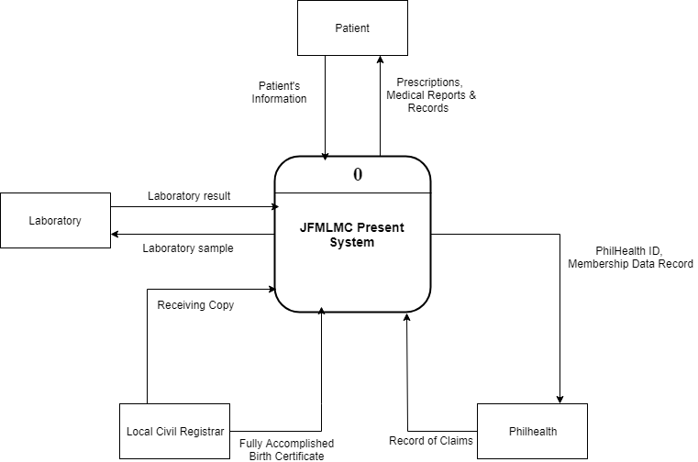

*Figure* 2. Context-level Diagram

Figure 2 presents the context level diagram of the existing system of Jewel’s First Maternity Lying-in and Medical Clinic. Patient’s records are sent to the manual pen-and-paper system and it will be stored in a file cabinet. Laboratory samples are sent in an external entity and it will receive the laboratory result. PhilHealth and Local Civil Registrar receive data about the pregnant and infant patients.

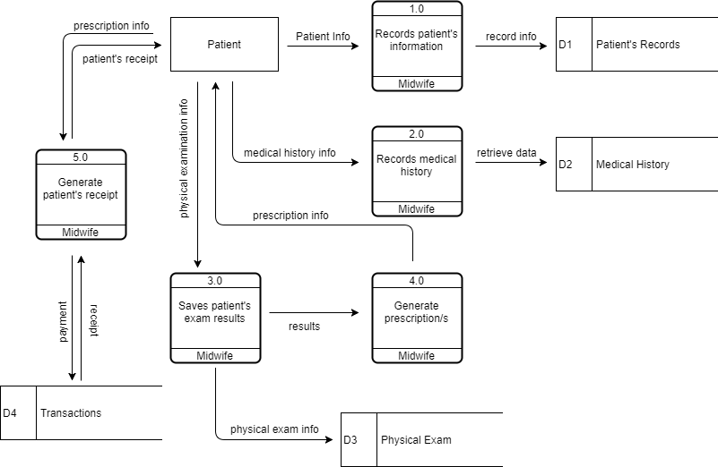

*Figure* 3**.** Top-level Data Flow Diagram

Figure 3 shows the prenatal process of old and new patients. New patients will undergo profiling before recording the medical history, physical examination, and to be followed by the prescription and receipt from the clinic. Additionally, the patients will pay the checkup fee.

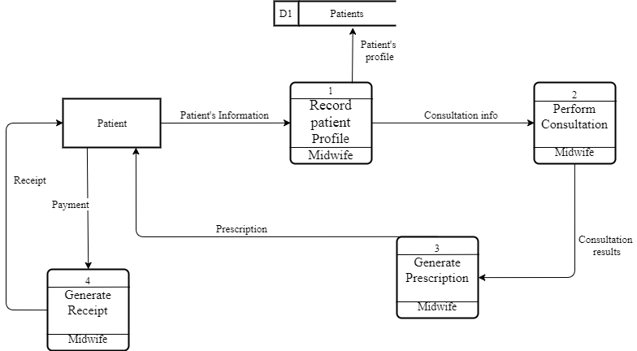

*Figure* 4.Top-level Data Flow Diagram

Figure 4 shows the process of the infant during the consultation process. Clinic’s midwife will retrieve the data of patient in their medical records. After checking patient’s info, consultation process performs. Before generating prescription for patient, consultation results are needed because of data dependency. After receiving the prescription given by the clinic, patent will undergo payment-receipt process.

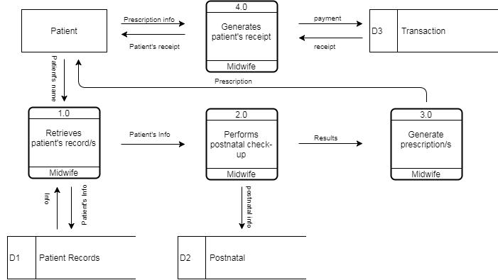

*Figure* 5.Top-level Data Flow Diagram

Figure 5 shows the process of postnatal checkup. Patient’s record will be retrieved by the midwife and will perform postnatal check-up to the patient. Before generating prescriptions, check-up results are needed because of data dependency. Patient receives the prescription and payment-receipt process happens.

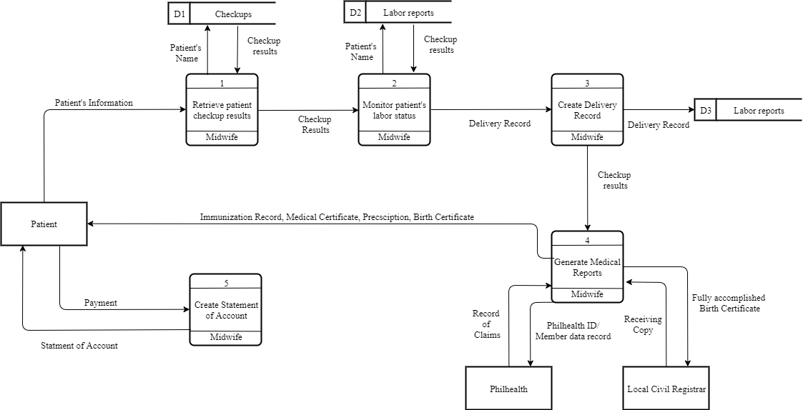

*Figure* 6.Top-level Data Flow Diagram

Figure 6 shows the childbirth process. First, patient’s record will be retrieve by midwife in their medical records, next, midwife will perform monitoring on patient’s labor status. Delivery record will be created depends on patient’s labor status. The midwife will receive check-up results of their patient and medical reports will be generated. Immunization record, medical record, prescription and birth certificate of patient’s child will be given to patient.

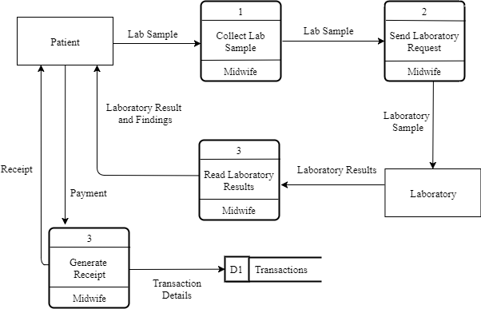

*Figure* 7.Top-level Data Flow Diagram

Figure 7 shows the laboratory request process. It is a clinical process wherein the patient will undergo checkup, getting blood platelets and blood pressure. Midwife will collect the patient’s laboratory sample and will send laboratory request. After examining patient’s lab sample, laboratory will produce results and clinic’s midwife will present it to their patient. Payment-receipt process will be happened after receiving laboratory results.

**Use Case Diagram**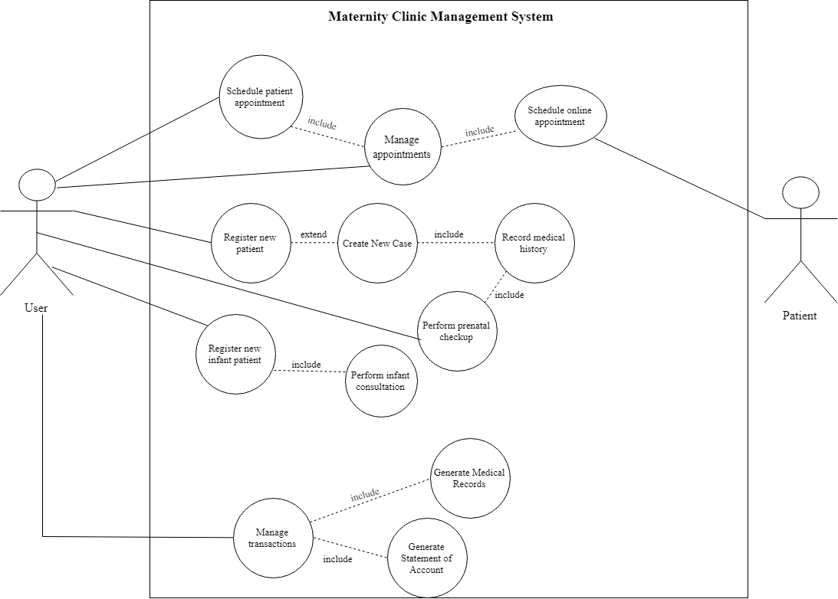

*Figure* 8.Use Case diagram of the proposed system

**Project Development**  
 For the project development, the researchers have decided to use the waterfall method from the System Development Life Cycle (SDLC). Figure 8 shows the detailed flowchart of waterfall method.

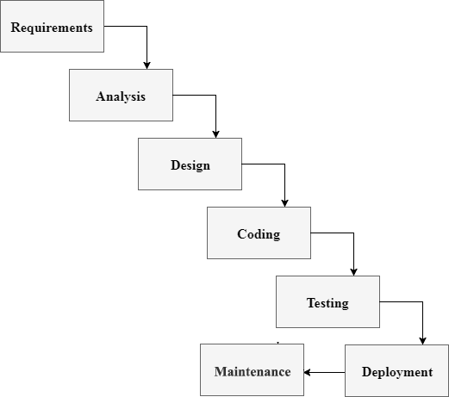

*Figure* 9.Waterfall Method

1. Requirements

In this phase, the researchers conducted set of interviews to Jewel’s First Maternity Lying-in and Medical Clinic to gather information that will be helpful throughout the study. Knowing the business process of the client is vital to know the scope and limitations of the study.

2. Analysis

With the acquired requirements and information about the client, the researchers proceeded to the analysis phase to examine the elements of the given information. With the help of the acquired information about the business process of Jewel’s First Maternity Lying-in and Medical Clinic, the researchers analyzed and had a conclusion about the objectives, scope and limitation of the study.

3. Design

In this phase, the researchers are preparing by creating diagrams that will help in creating the system. For the researchers, the design phase is very important because this will be the phase that will determine the whole system. Design phase will determine the overall usefulness and functionality through creating diagrams and schemas. Dataflow diagram (DFD) is used to show the existing processes and how data is being used. Entity relationship diagram (ERD) is used to show the logical structure of database and their relationship. The researchers did not limit the design phase into creating diagrams, user interface was also discussed and planned during this phase.

4.Coding  
 In this phase, the information from the previous steps are gathered and the actual coding is started. The researchers dedicated most of time planned in this phase since the coding phase consumes a lot of time. This phase is the longest and considered the critical stage.

5. Testing

In this phase the researchers used Unit Testing Class of CodeIgniter to test the system. The said class is a simple evaluation of the code to determine if it produces the correct data type set and result.

6. Deployment

The deployment phase is the moment that the system is get tested and ready to be deployed for Jewel’s First Maternity Lying-in and Medical Clinic. User Acceptance Testing (UAT) is talking about the deployment of the system wherein the improvements and debugging are still occurring because of the client’s suggestions and needs. These suggestions are reported directly into the researchers to update all the necessary concerns that the user is concern for.

7. Maintenance

Maintenance is the last phase and considered as one of the most important phase in waterfall method. To make sure that the system is up and running, the researchers will conduct a weekly consultation with the Jewel’s First Maternity Lying-in and Medical Clinic about the system. This consultation will help solve any problems occurred in the system or any other concern.

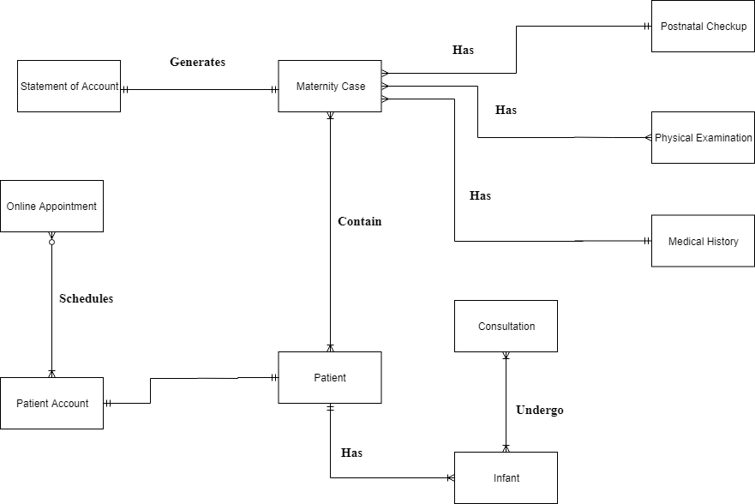**Entity Relationship Diagram**

*Figure* 10.Entity Relationship Diagram of the proposed system

**Operation and Testing Procedure** For the operation and testing of the system, the following steps will be conducted by the researchers.

**Table 1.** *Functionality Test*

|  |  |
| --- | --- |
| Modules | Steps Undertaken |
| Patient record management module | 1. Clicked “Add New Maternity Case”  2. Clicked “New Patient”  3. Populated required fields for profiling  4. Submitted profiling form and proceed to Medical History  5. Populated required fields for Medical History  6. Submitted form and proceed to Physical Examination  7. Submit form |
| Patient profiles module | 1. Clicked “Patients” in the navigation bar  2. Searched patient’s name in the search bar  3. Clicked “View Profile” |
| Online appointment module | 1. Clicked “Book Now” button  2. Input patient username and password, and clicked “Login” button  3. Clicked “Schedule an Appointment” in navigation bar  4. Inserted preferred time and date of appointment  5. clicked “Schedule” button |
| Medical report module | 1. Clicked “Maternity Cases” in the navigation bar  2. Searched the maternity case and clicked “View Maternity Case” button  3. Clicked “Generate Maternity Case Summary” button |

Table 1 shows the series of procedures taken during the testing procedure. Each module of the system undergoes through a series of steps. After testing each of the system’s module, the results were observed to ensure the system’s functionality.

**Evaluation Procedure**

The project was evaluated by 45 students from Computer Students’ Association of the Technological University of the Philippines. The following steps were performed:

1. Evaluation sheets were given to each respondent;
2. Respondents was given a chance to test and evaluate the system after the researchers discussed the capabilities and flow of the system;
3. The respondents rated the system using the rating scale in Table 2;
4. The data were tabulated, and the computed mean ratings were calculated to determine if the system is acceptable;
5. Mean ratings were interpreted to determine the equivalent descriptive rating presented in Table 3.

**Statistical Method**

Mean average was computed to determine the acceptability of the system. The formula below shows the formula to get the mean average (x) which can be obtained by the summation of all the resulted data () and dividing it by the number of respondents (n).

*Figure* 11. Statistical Mean Method

**Table 2.** *Rating Scale for Evaluation Instrument*

|  |  |
| --- | --- |
| Numerical Rating | Descriptive Rating |
| 4 3 2 1 | Highly Acceptable Very Acceptable Acceptable Not Acceptable |

As shown in Table 2, the indicators were rated from the scale of 1 to 4 with 1 being the lowest or “Not Acceptable” and 4 as the highest or “Highly Acceptable”.

**Table 3.** *Numerical Range and its Qualitative Interpretation*

|  |  |
| --- | --- |
| Numerical Rating | Qualitative Interpretation |
| 3.4-40 2.6-3.3 1.8-2.5 1.0-1.7 | Highly Acceptable Very Acceptable Acceptable Not Acceptable |

Table 3 shows the Likert Scale used to interpret the results of evaluation, where the range of 3.4 – 4.0 is highly acceptable, 2.6 - 3.3 as very acceptable, 1.8 – 2.5 as acceptable, and 1.0 – 1.7 as not acceptable.

**Chapter 4**

**RESULTS AND DISCUSSION**

This chapter discusses the project description, project structure, project capabilities and limitations, and project evaluation.

**Project Description**

The project is about Medical Clinic Management System for Jewel’s First Maternity and Lying-in and Medical Clinic.

The web-based system provides a quick and easy way to its client. The management system can create and update patient’s record, generate medical and report. The system provides features that manage or monitor the patient’s health development through vital statistics, diagnosis, medications and medical findings. The administrator could check it by viewing available growth charts for both patients and infants.

**Project Structure**

The project structure contains screenshots and forms used in the program with its description and functions in the software.

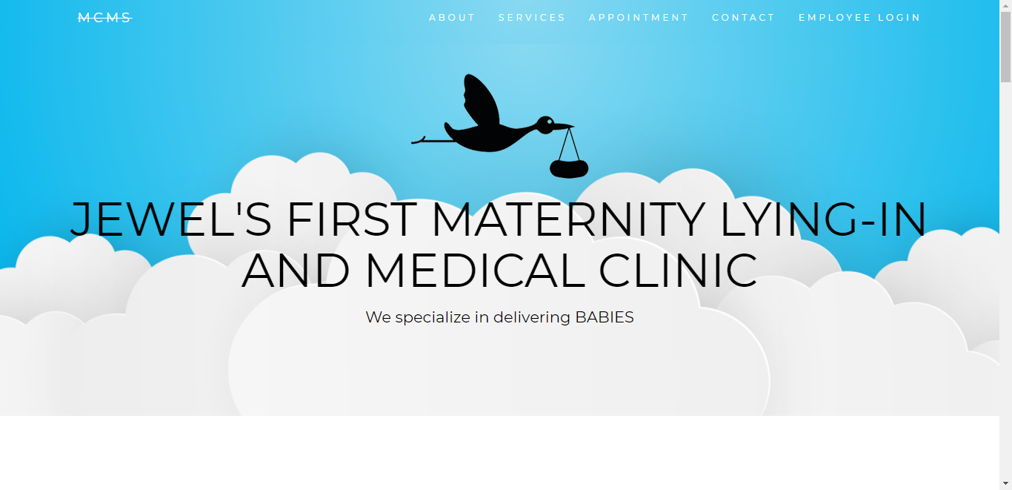

*Figure* 12.MCMS Homepage

Figure 12 displays the imformation about the clinic such as clinic’s overview, core values, services, contact number, and location.

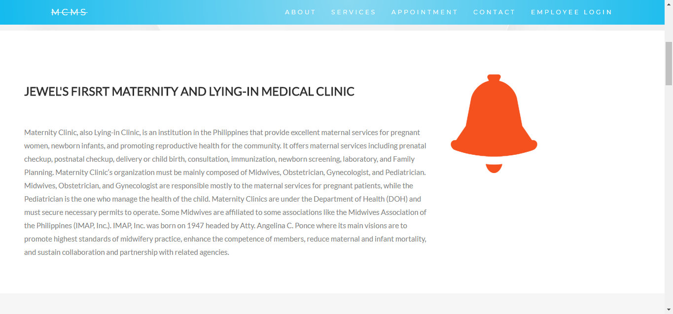

*Figure* 13**.** JFMLMC’s information

Figure 13 is where you can find the information about the clinic, history and other overview.

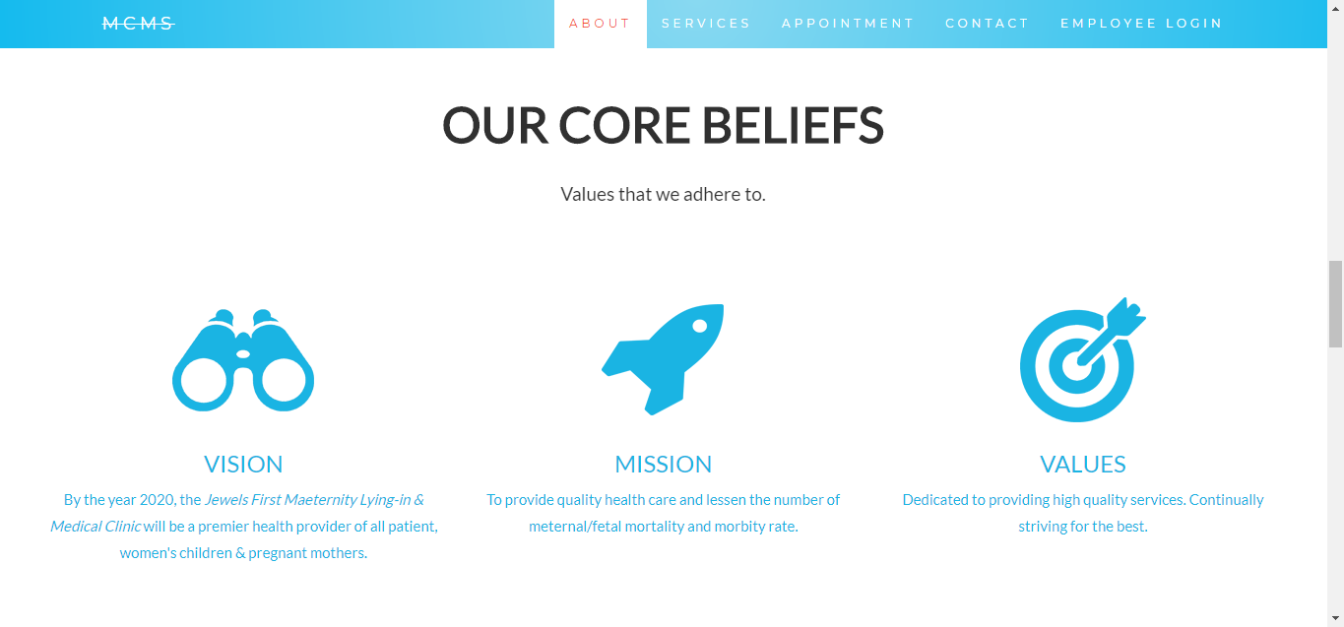

*Figure* 14.Core Beliefs

Figure 14 displays about the core beliefs of the clinic. This includes the client’s vision, mision, and values.

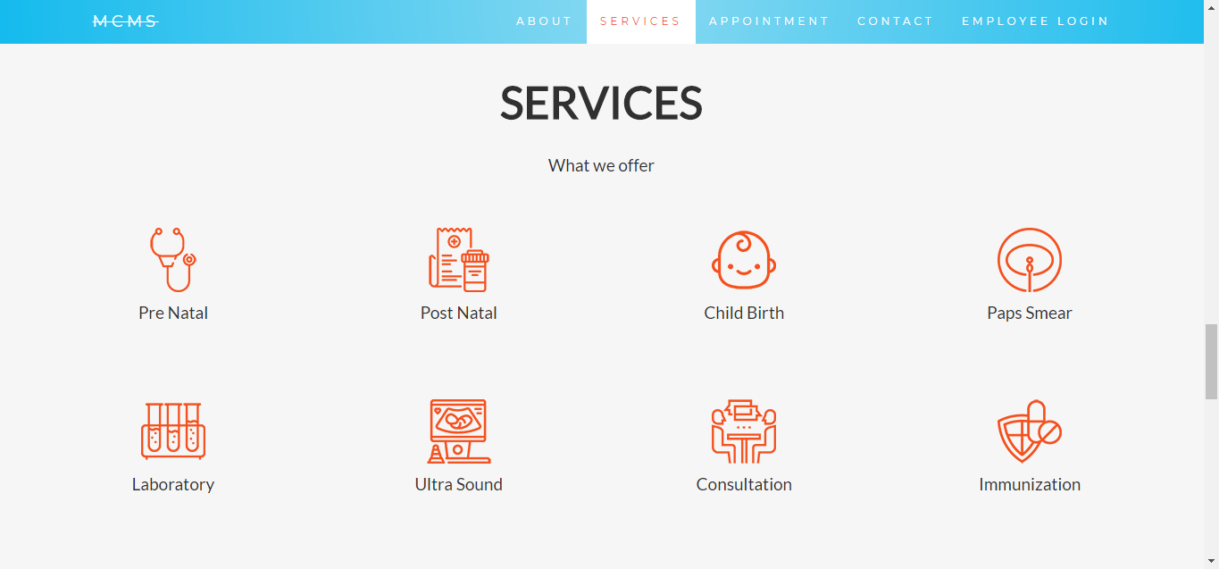

*Figure* 15.Services Offered

Figure 15 shows the services offered by JFMLMC. There are prenatal, post natal, childbirth, paps smear, laboratory, ultrasound, consultation, and immunization.



*Figure* 16.Online Appointment Panel

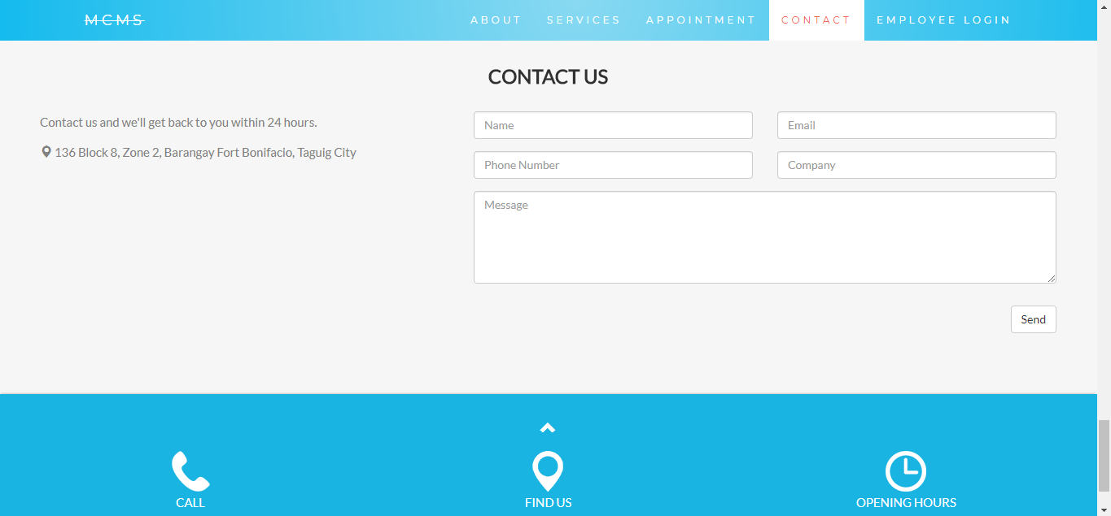 Figure 16 is where you can book an pointment that leads to Figure 18. This panel has a Call-to-action button of “Book Now”.

*Figure* 17.Contact Us Form

Figure 17 shows the “Contact Us” form. This form can be filled-up by visitors of the website to give their feedback.

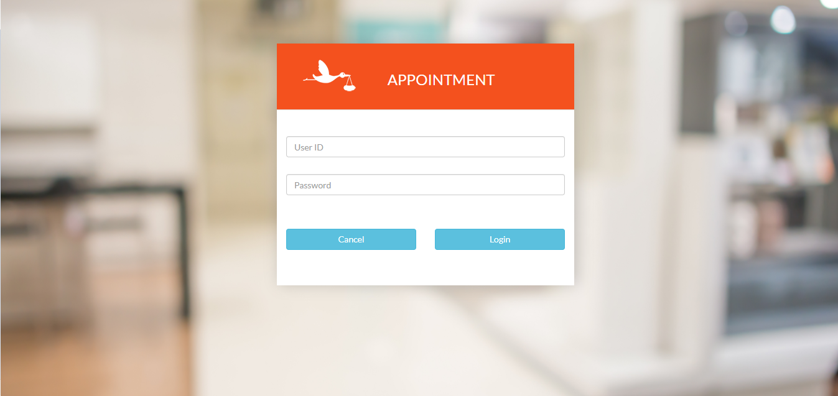

*Figure* 18.Patient’s Login

Figure 18 is the login page for a patient with existing records in the system.

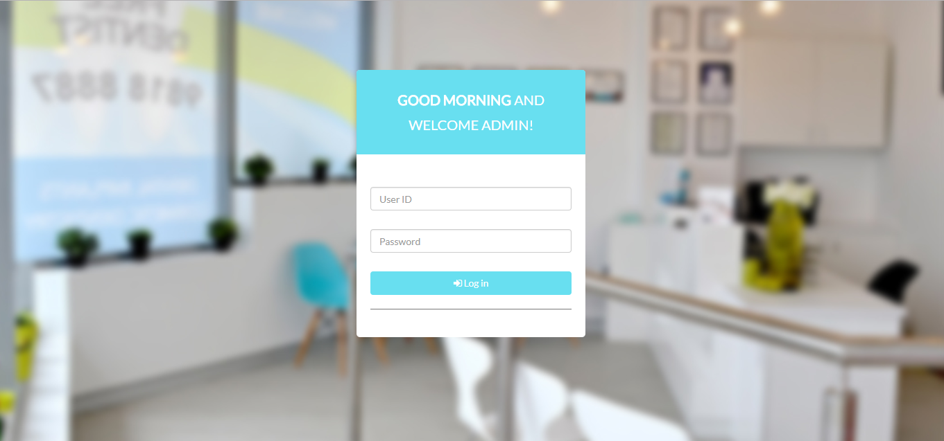

*Figure* 19.Login Page

Figure 19 shows the login page for Admin. With correct usernameand password the page will redirect you to Figure 21, Admin Dashboard.

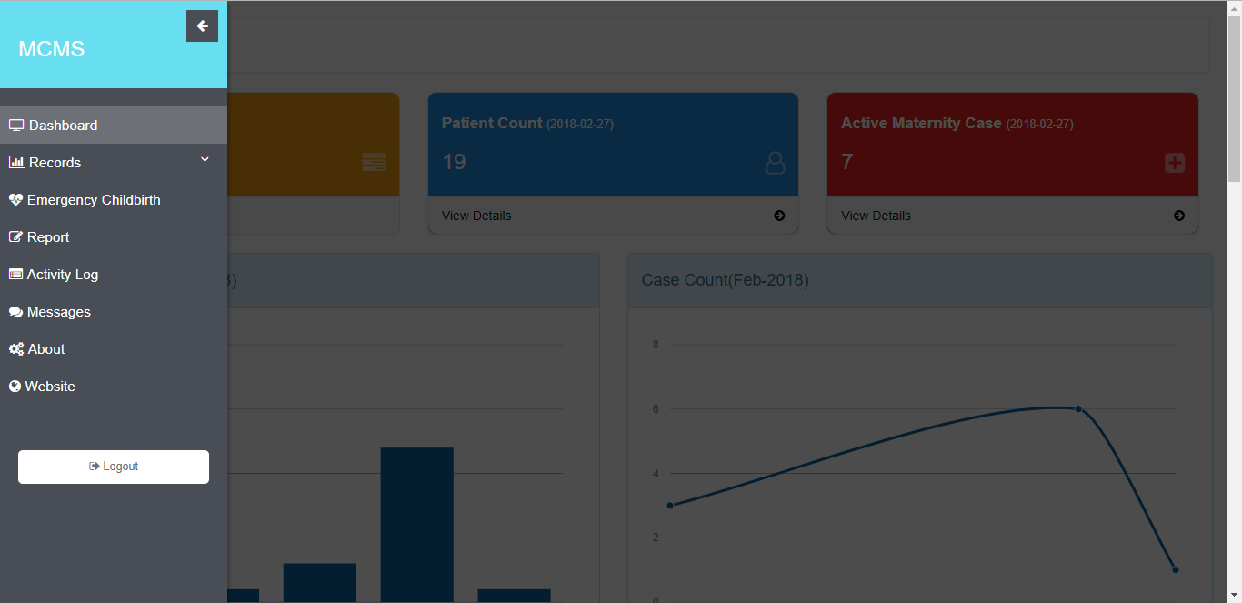

*Figure* 20.Side Navigation Bar

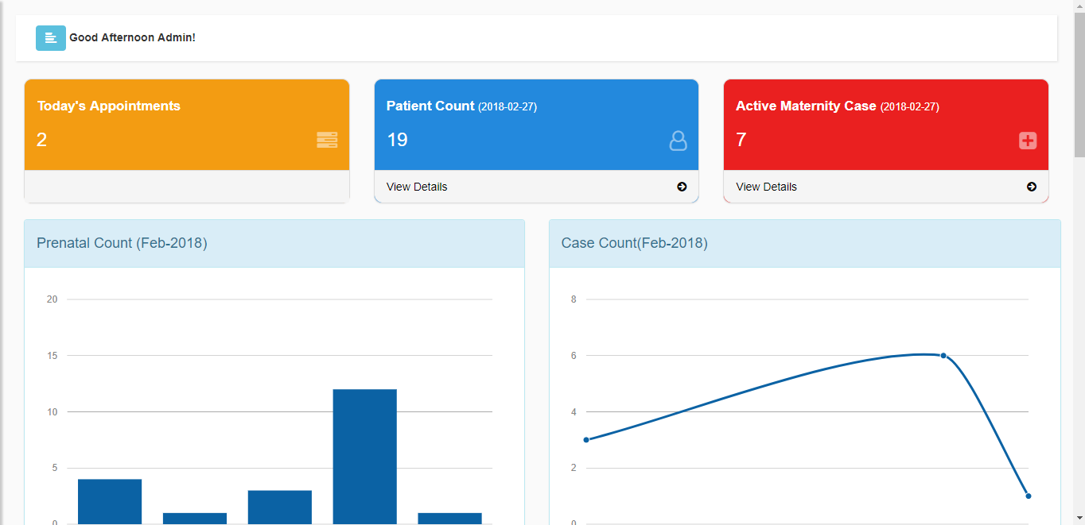 Figure 20 shows the side navigation bar. It is composed of Dashboard, Records, Emergency Childbirth, Report, Activity Log, Messages, About, Website, and Logout button.

*Figure* 21. Dashboard

Figure 21 displays significant numbers. These numbers are Today’s Appointment, Patient Count, and Active Maternity Cases. It also shows a graph for prenatal count and case count on the current month.

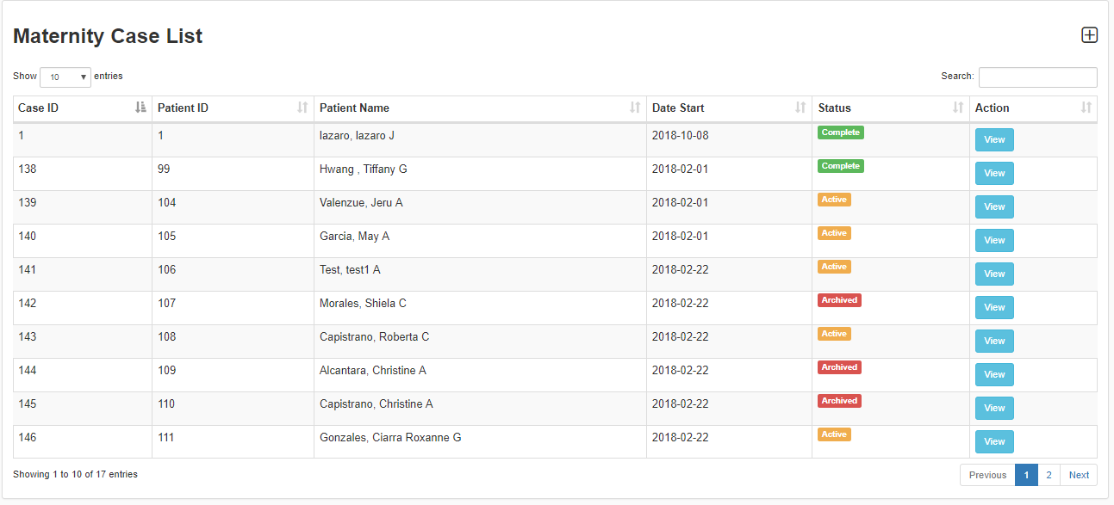

*Figure* 22.Maternity Case List

Figure 22 shows the page shows the table of all the maternity cases of the clinic. The status of maternity cases included here as follows: Active, For Postnatal, Complete, and Archived. You can also create new maternity case by clicking the cross button located in the upper-right.

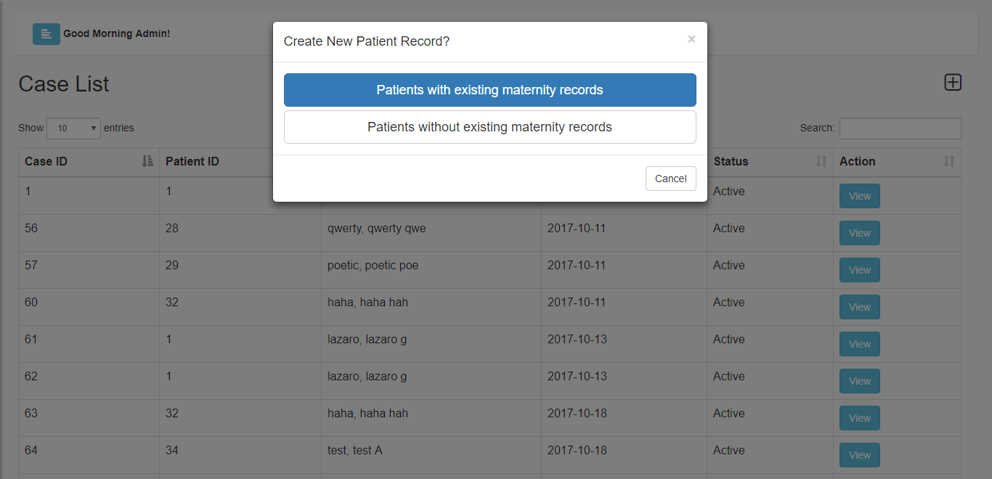

*Figure* 23.Creating new maternity case

Figures 23 displays a modal for the option on creating a new maternity case. The user has an option of creating a new maternity case where a patient has no existing records, or a patient with existing records.

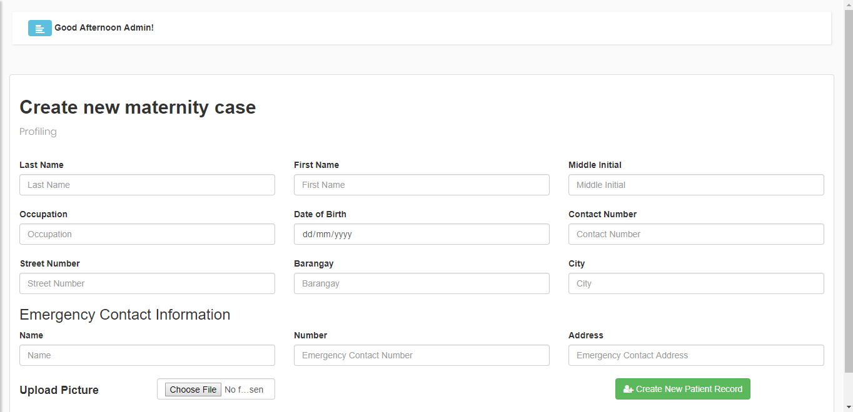

*Figure* 24.Profiling

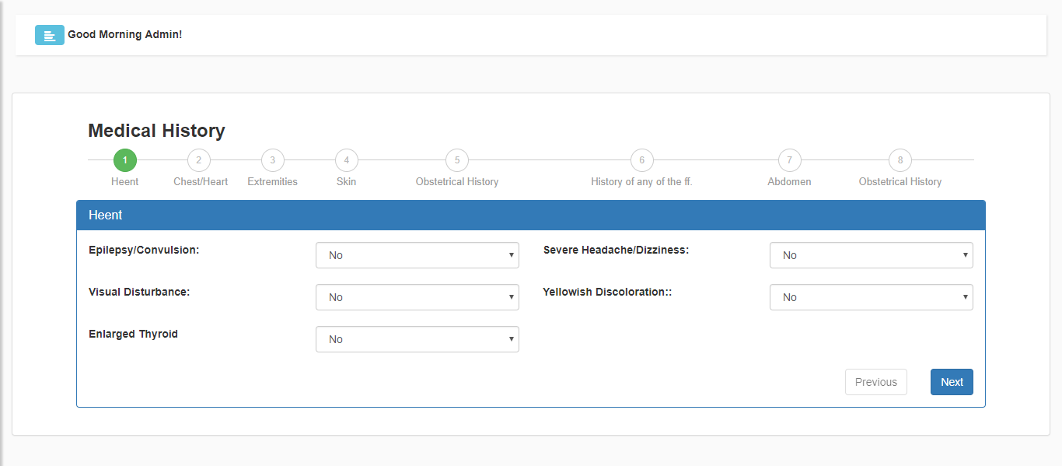 Figure 24 shows the profiling form. A pregnant patient will undergo profiling before creating a new maternity case. The user will input patient’s basic information.

*Figure* 25. Medical History

Figure 25 shows the form for recording the medical history. The checkup procedure is composed of recording the heent, chest/heart, extremities, skin, history of patient’s condition, abdomen, and obstetrical history.

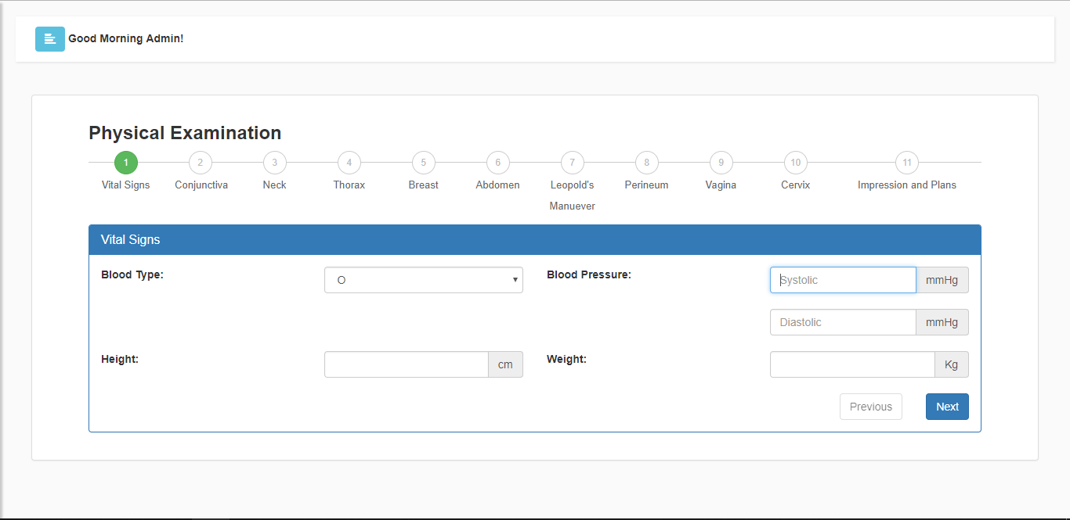

*Figure* 26.Physical Examination

Figure 26 displays the form for recording the physical examination. The physical examination is composed of recording the vital signs, conjunctiva, neck, thorax, breast, abdomen, Leopold’s maneuver, perineum, vagina, and cervix. Impression and plans are also included.

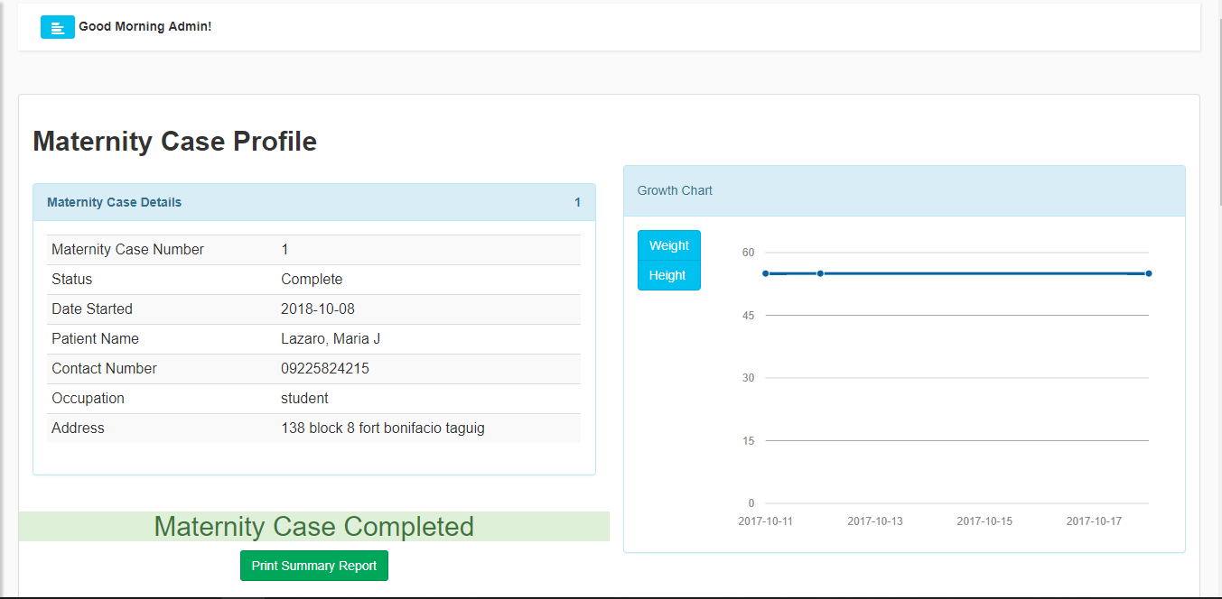

*Figure* 27. Maternity Case Profile

Figure 27 shows the profile of a maternity case. This include information about the maternity case and the patient. It also shows the growth chart of the patient during the whole duration of pregnancy.

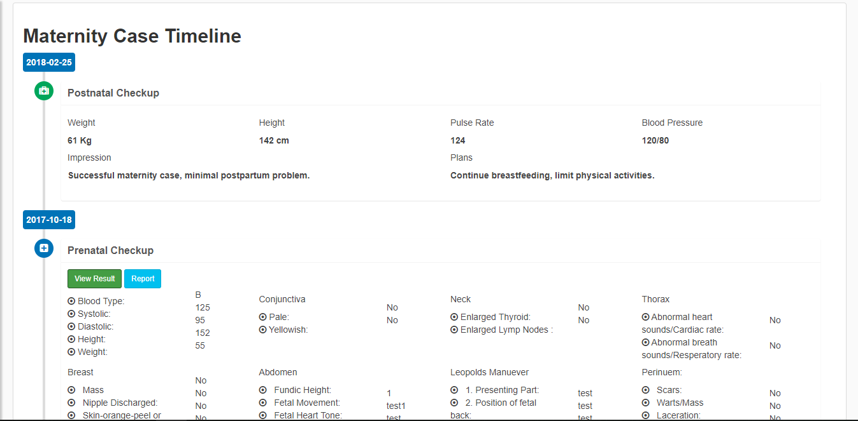

*Figure* 28.Maternity Case Timeline

Figure 28 shows the timeline of the maternity case. It is composed of postnatal checkup result, prenatal checkup result, and medical history result. The timeline will be the guide of the midwives to compare checkup results, monitor the status of the patient, and to predict the problems on maternity case and childbirth.

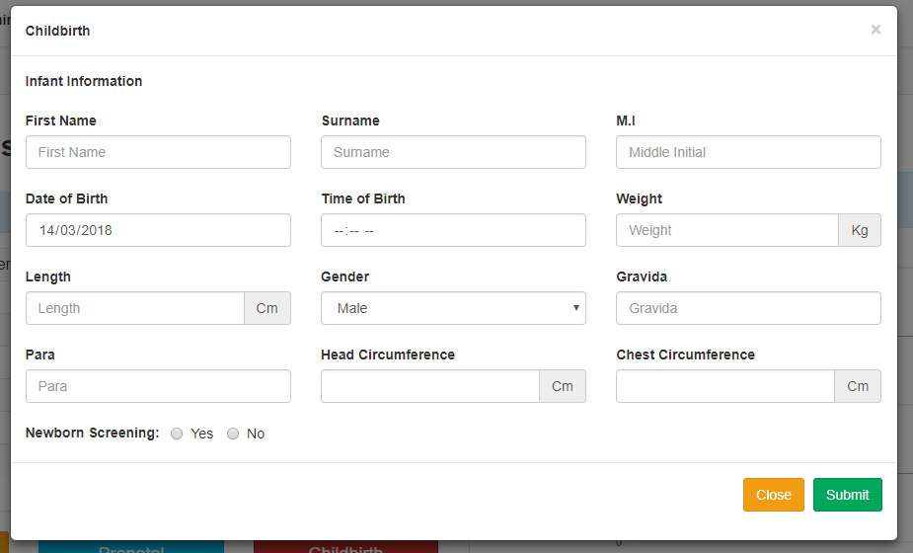

*Figure* 29.Childbirth Modal

Figure 29 displays the childbirth modal. It is composed of the infant’s information, gravida, para, head circumference, chest circumference, and newborn screening.

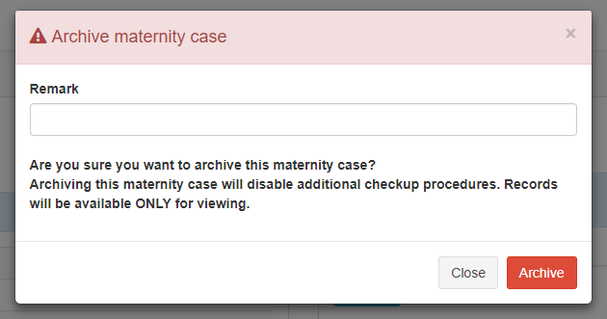

*Figure* 30.Archive Maternity Case Modal

Figure 30 shows the modal on archiving a maternity case. Once a maternity case is archived, adding checkup procedures will no longer be available and the maternity case will be only available for viewing.

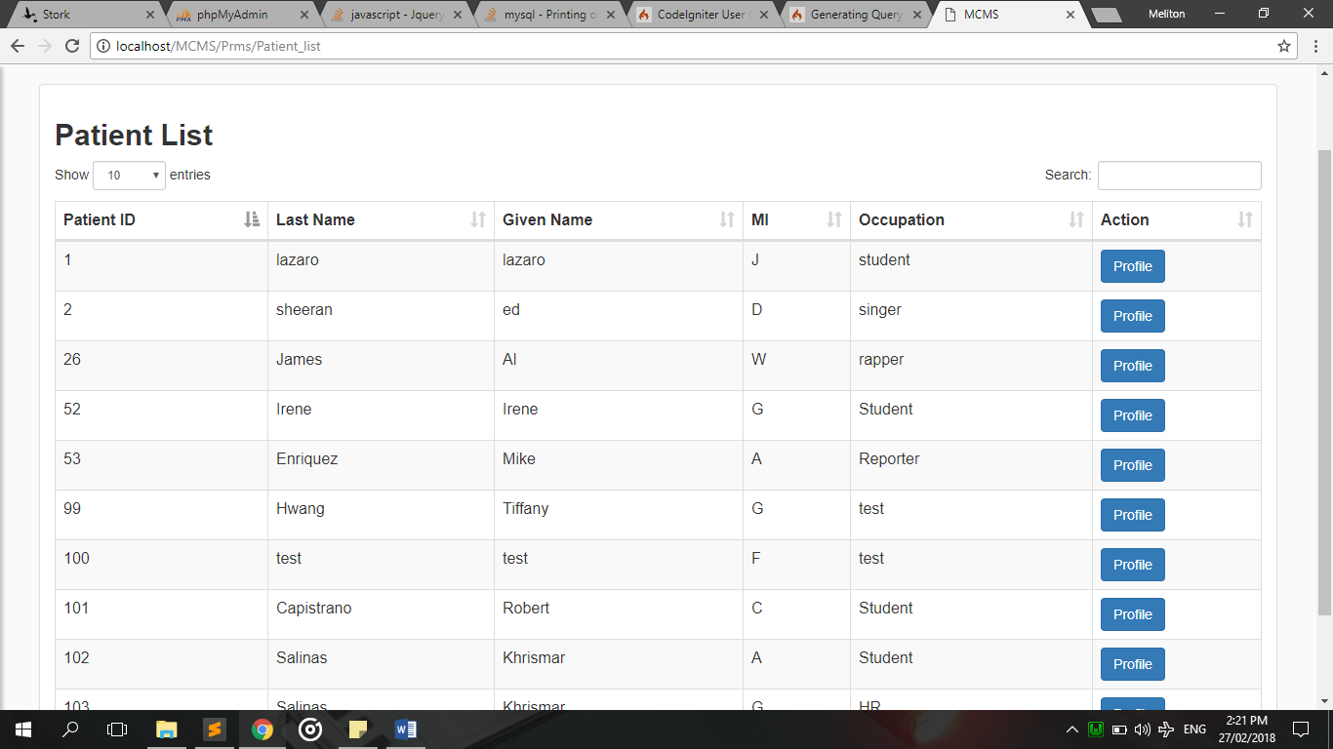

*Figure* 31. Patient List

Figure 31 shows the list of the patient. When “Profile” button is clicked, it will lead to Patient Profile.

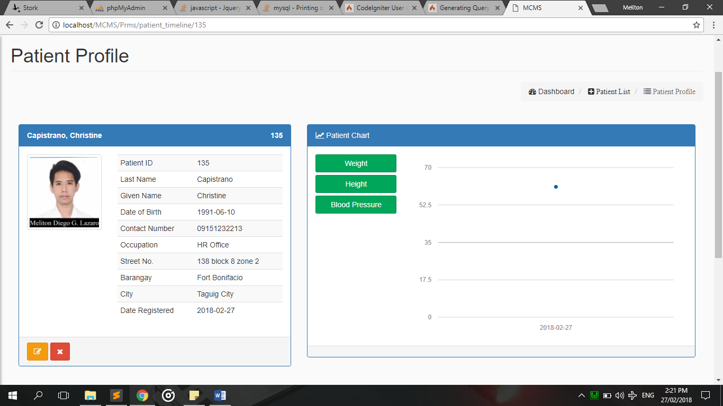

*Figure* 32. Patient Profile

Figure 32 shows the profile of the patient, it includes the patient’s basic information, growth chart, and a timeline that lists down her maternity cases.

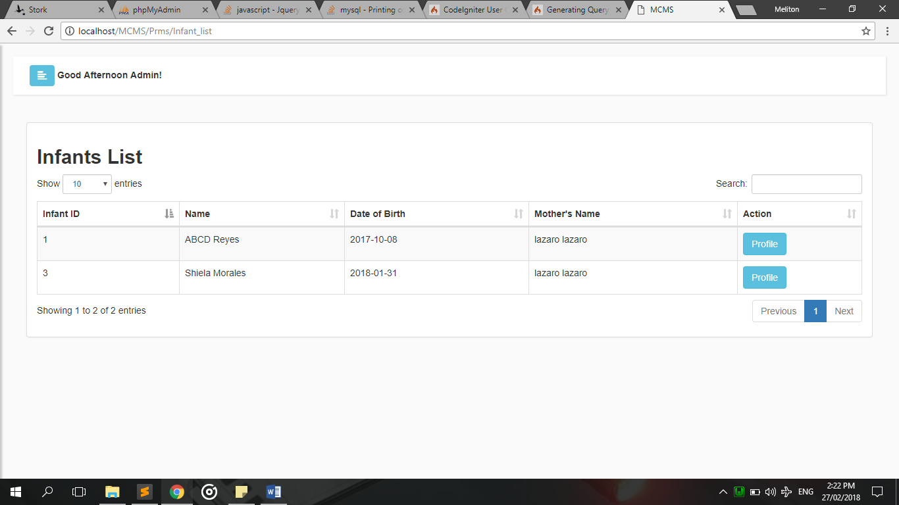

*Figure* 33.Infant List

Figure 33 shows the infants table. The table displays the date of birth and the mother’s name of the infant. The “Profile” button will redirect the user to the Infant’s Profile.

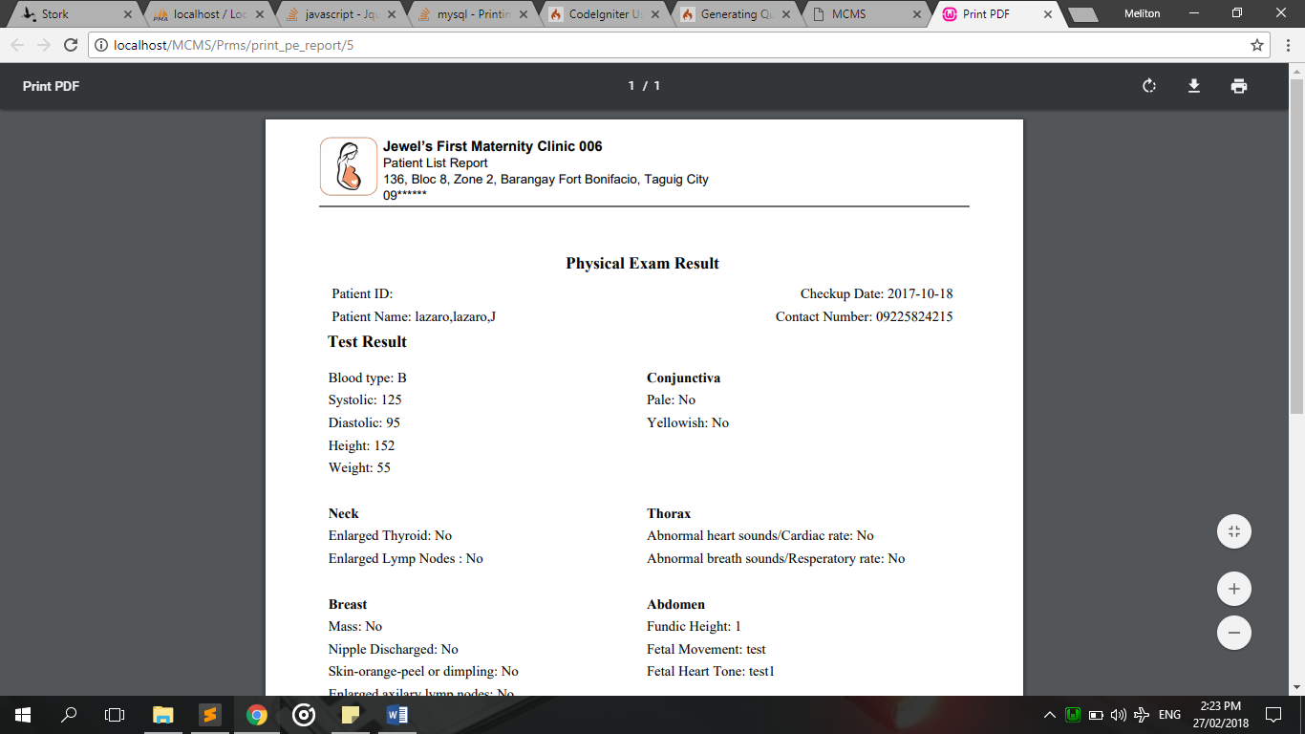

*Figure* 34.Physical Examination Report

Figure 34 displays the example of generated PDF report of a chosen patient and result of selected physical examination, all the checkup information from physical examination are displayed.

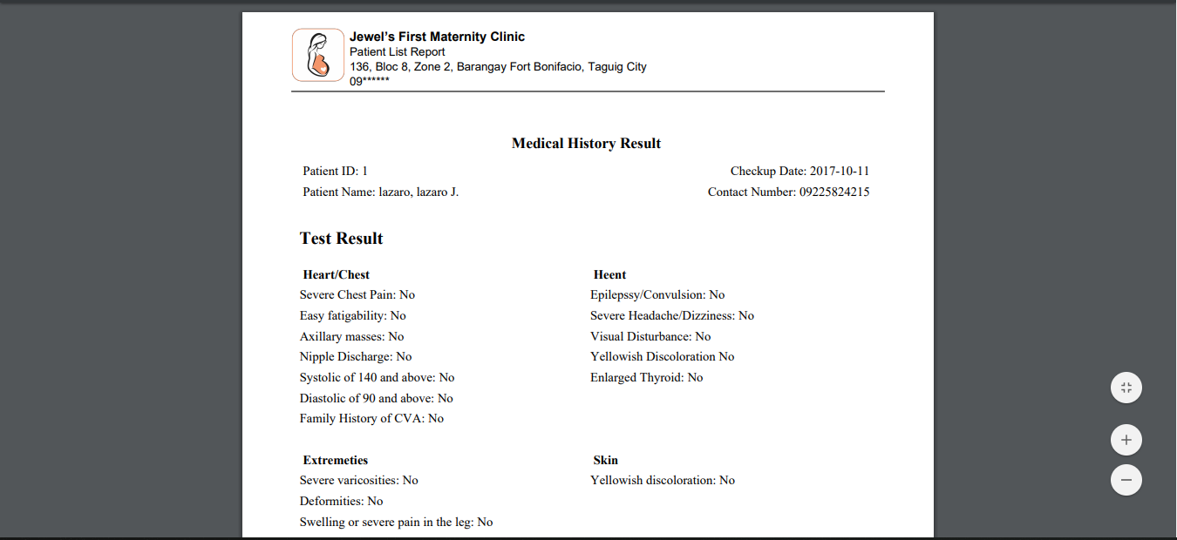

*Figure* 35.Medical History Report

Figure 35 displays the example of generated PDF report of a chosen patient and result of selected medical history, all the checkup information from medical history are displayed.

**Project Capabilities and Limitations**

The following are the capabilities of the developed system:

1. For data security, the system securely and confidentially keeping information of every individual/patient of the MCMS
2. The system provides the admin an automated Patient Record Management System
3. For existing patient they're able to book an appointment in the web page interface.
4. For billing, the system can generate a statement account for about the expenses of childbirth.
5. The system can also provide an overall record of chosen time frame format as PDF.

Just like any other systems, the system has the following limitations:

1. A patient with no existing records won't be able to book an appointment online.
2. Laboratory result are not provided by the Clinic
3. Recording labor information of patients during childbirth and centralizing the database of two clinic branches are not included in the system.

**Project Evaluation**

The system was evaluated by 50 evaluators, 5 are professionals whereas the other 45 are students are members of Computer Students’ Association in Technological University of the Philippines (TUP) Manila.

**Test Results**

The system’s functional suitability evaluation result is shown in Table 4. 91.33% of the respondents rated with a score of 4 or “Highly Acceptable” and 8.67% rated with a score of 3 or “Very Acceptable” while 0% rated with a score of 2 or “Acceptable” and 1 or “Not Acceptable”.

**Table 4**. *Functional Suitability Evaluation Result*

|  |  |  |  |  |
| --- | --- | --- | --- | --- |
| CRITERIA | 4 | 3 | 2 | 1 |
| Functional Suitability |  |  |  |  |
| 1. Functional Completeness | 45 (90%) | 5 (10%) | 0 | 0 |
| 1. Functional Correctness | 46 (92%) | 4 (8%) | 0 | 0 |
| 1. Functional Appropriateness | 46 (92%) | 4 (8%) | 0 | 0 |
|  |  |  |  |  |
| Overall Percentage | **91.33%** | **8.67%** | **0%** | **0%** |

The system’s performance efficiency evaluation result is shown in Table 5. 84% of the respondents rated with a score of 4 or “Highly Acceptable” and 16% rated with a score of 3 or “Very Acceptable” while 0% rated with a score of 2 or “Acceptable” and 1 or “Not Acceptable”.

**Table 5**. *Performance Efficiency Evaluation Result*

|  |  |  |  |  |
| --- | --- | --- | --- | --- |
| **CRITERIA** | **4** | **3** | **2** | **1** |
| **Performance Efficiency** |  |  |  |  |
| 1. Time Behavior | 42 (84%) | 8 (16%) | 0 | 0 |
| 1. Resource Utilization | 40 (80%) | 10 (20%) | 0 | 0 |
| 1. Capacity | 44 (88%) | 6 (12%) | 0 | 0 |
|  |  |  |  |  |
| **Overall Percentage** | **84%** | **16%** | **0%** | **0%** |

The system’s compatibility evaluation result is shown in Table 6. 84% of the respondents rated with a score of 4 or “Highly Acceptable” and 16% rated with a score of 3 or “Very Acceptable” while 0% rated with a score of 2 or “Acceptable” and 1 or “Not Acceptable”.

**Table 6**. *Compatibility Evaluation Result*

|  |  |  |  |  |
| --- | --- | --- | --- | --- |
| **CRITERIA** | **4** | **3** | **2** | **1** |
| **Compatibility** |  |  |  |  |
| 1. Co-existence | 42 (84%) | 8 (16%) | 0 | 0 |
| 1. Interoperability | 42 (84%) | 8 (16%) | 0 | 0 |
|  |  |  |  |  |
| **Overall Percentage** | **84%** | **16%** | **0%** | **0%** |

The system’s usability evaluation result is shown in Table 7. 85.67% of the respondents rated with a score of 4 or “Highly Acceptable”, 13.67% rated with a score of 3 or “Very Acceptable”, and 0.67% rated with a score of 2 or “Acceptable” while 0% rated with a score of 1 or “Not Acceptable”.

**Table 7**. *Usability Evaluation Result*

|  |  |  |  |  |
| --- | --- | --- | --- | --- |
| **CRITERIA** | **4** | **3** | **2** | **1** |
| **Usability** |  |  |  |  |
| 1. Appropriateness Recognizability | 44 (88%) | 6 (12%) | 0 | 0 |
| 1. Learnability | 41 (82%) | 9 (18%) | 0 | 0 |
| 1. Operability | 43 (86%) | 6 (12%) | 1 (2%) | 0 |
| 1. User Error Protection | 42 (84%) | 7 (14%) | 1 (2%) | 0 |
| 1. User Interface Aesthetics | 42 (84%) | 8 (16%) | 0 | 0 |
| 1. Accessibility | 45 (90%) | 5 (10%) | 0 | 0 |
|  |  |  |  |  |
| **Overall Percentage** | **85.67%** | **13.67%** | **0.67%** | **0%** |

The system’s reliability evaluation result is shown in Table 8. 86.5% of the respondents rated with a score of 4 or “Highly Acceptable”, 13% rated with a score of 3 or “Very Acceptable”, and 0.5% rated with a score of 2 or “Acceptable” while 0% rated with a score of 1 or “Not Acceptable”.

**Table 8**. *Reliability Evaluation Result*

|  |  |  |  |  |
| --- | --- | --- | --- | --- |
| **CRITERIA** | **4** | **3** | **2** | **1** |
| **Reliability** |  |  |  |  |
| 1. Maturity | 47 (94%) | 2 (4%) | 1 (2%) | 0 |
| 1. Availability | 43 (86%) | 7 (14%) | 0 | 0 |
| 1. Fault Tolerance | 39 (78%) | 11 (22%) | 0 | 0 |
| 1. Recoverability | 44 (88%) | 6 (12%) | 0 | 0 |
|  |  |  |  |  |
| **Overall Percentage** | **86.5%** | **13%** | **0.5%** | **0%** |

The system’s security evaluation result is shown in Table 9. 88% of the respondents rated with a score of 4 or “Highly Acceptable”, 12% rated with a score of 3 or “Very Acceptable” while 0% rated with a score of 2 or “Acceptable” and 1 or “Not Acceptable”.

**Table 9**. *Security Evaluation Result*

|  |  |  |  |  |
| --- | --- | --- | --- | --- |
| **CRITERIA** | **4** | **3** | **2** | **1** |
| **Security** |  |  |  |  |
| 1. Confidentiality | 46 (92%) | 4 (8%) | 0 | 0 |
| 1. Integrity | 47 (94%) | 3 (6%) | 0 | 0 |
| 1. Non-repudiation | 42 (84%) | 8 (16%) | 0 | 0 |
| 1. Accountability | 42 (84%) | 8 (16%) | 0 | 0 |
| 1. Authenticity | 43 (86%) | 7 (14%) | 0 | 0 |
|  |  |  |  |  |
| **Overall Percentage** | **88%** | **12%** | **0%** | **0%** |

The system’s maintainability evaluation result is shown in Table 10. 85.6% of the respondents rated with a score of 4 or “Highly Acceptable”, 14.4% rated with a score of 3 or “Very Acceptable” while 0% rated with a score of 2 or “Acceptable” and 1 or “Not Acceptable”.

**Table 10**. *Maintainability Evaluation Result*

|  |  |  |  |  |
| --- | --- | --- | --- | --- |
| **CRITERIA** | **4** | **3** | **2** | **1** |
| **Maintainability** |  |  |  |  |
| 1. Modularity | 43 (86%) | 7 (14%) | 0 | 0 |
| 1. Reusability | 40 (80%) | 10 (20%) | 0 | 0 |
| 1. Analyzability | 46 (92%) | 4 (8%) | 0 | 0 |
| 1. Modifiability | 44 (88%) | 6 (12%) | 0 | 0 |
| 1. Testability | 41 (82%) | 9 (18%) | 0 | 0 |
|  |  |  |  |  |
| **Overall Percentage** | **85.6%** | **14.4%** | **0%** | **0%** |

The system’s portability evaluation result is shown in Table 11. 86% of the respondents rated with a score of 4 or “Highly Acceptable”, 14% rated with a score of 3 or “Very Acceptable” while 0% rated with a score of 2 or “Acceptable” and 1 or “Not Acceptable”.

**Table 11**. *Portability Evaluation Result*

|  |  |  |  |  |
| --- | --- | --- | --- | --- |
| **CRITERIA** | **4** | **3** | **2** | **1** |
| **Portability** |  |  |  |  |
| 1. Adaptability | 45 (90%) | 5 (10%) | 0 | 0 |
| 1. Installability | 40 (80%) | 10 (20%) | 0 | 0 |
| 1. Replaceability | 44 (88%) | 6 (12%) | 0 | 0 |
|  |  |  |  |  |
| **Overall Percentage** | **86%** | **14%** | **0%** | **0%** |

The system’s portability evaluation result is shown in Table 12. 86% of the respondents rated with a score of 4 or “Highly Acceptable”, 14% rated with a score of 3 or “Very Acceptable” while 0% rated with a score of 2 or “Acceptable” and 1 or “Not Acceptable”.

**Table 12**. *Overall Percentage Frequency of Evaluation Result*

|  |  |  |  |  |
| --- | --- | --- | --- | --- |
| **CRITERIA** | **4** | **3** | **2** | **1** |
| **Overall** |  |  |  |  |
| Functional Suitability | 91.33% | 8.67% | 0 | 0 |
| Performance Efficiency | 84% | 16% | 0 | 0 |
| Compatibility | 84% | 16% | 0 | 0 |
| Usability | 85.67% | 13.67% | 0.67% | 0 |
| Reliability | 86.5% | 13% | 0.5% | 0 |
| Security | 88% | 12% | 0 | 0 |
| Maintainability | 85.6% | 14.4% | 0 | 0 |
| Portability | 86% | 4% | 0 | 0 |
|  |  |  |  |  |
| **Overall Percentage Frequency** | **86.39%** | **12.22%** | **0.15%** | **0** |

Overall, the system was rated with a score of 4 or “Highly Acceptable” by the 86.39% of all the respondents from each of the criterion. 12.22% of the respondents rated the system with a score of 3 or “Very Acceptable”.

**Chapter 5**

**SUMMARY OF FINDINGS, CONCLUSIONS AND RECOMMENDATIONS**

This chapter contains the summary of findings, conclusions and recommendations derived to further improve the system.

**Summary of Findings**

The developed system was able to: (1) web-based appointment booking (2) manage reports of physical examination and medical history (3) automatically generate statement of account and (4) effectively manage and store records regarding MCMS.

The researchers do find 50 people to evaluate the acceptability of the system. Those 50 people is composed of 5 professionals and 45 students within the Computer Association in this university. The findings of the evaluation are the following:

1. 91.33% of the respondents considers the system’s functional suitability are highly acceptable which means that the functions of the system were complete, correct, and appropriate for the needs of the end-users.
2. 84% of the respondents were amazed with the system’s performance efficiency and gave a score of 4 or “Highly Acceptable”.
3. The compatibility criterion garnered a highly acceptable score from 84% of the respondents which means that the system can co-exist with other products and is interoperable.
4. 85.67% of the respondents were impressed with the system’s usability thus giving in a mark of highly acceptable.
5. The system’s reliability is highly acceptable according to 86.5% of the respondents.
6. According to 88% of the respondents, the system’s security is highly acceptable.
7. The system garnered a highly acceptable mark from 85.6% of the respondents which means that the system is reusable and modifiable.
8. The portability criterion was marked highly acceptable by 86% of the respondents which mean that the system can adapt to changes in SPMS.

86.39% of the evaluators have given the system a score of 4 in each criterion which can be interpreted as “Highly Acceptable”.

**Conclusions**

The following conclusions were drawn from this study:

1. Web-based of Jewel’s Maternity and Lying in Medical Clinic was successfully designed by having the following features:
   1. Jewel’s Maternity and Lying-in Clinic inquiry website.
   2. Electronically process of profiling patient to facilitate paperless forms.
   3. Online appointment
   4. Generated statement of account.
   5. Over all report as PDF
   6. Centralized information for easy access of any information.
2. The system was created using CodeIgniter (PHP framework), Bootstrap, WAMP (Windows, Apache HTTP Server, MySQL, and PHP: Hypertext Preprocessor) server, MySQL Workbench, Atom text editor, and Google Chrome web browser.
3. The system was tested and improved in terms of functionality, accuracy, and security.
4. The system was evaluated using ISO 25010 as quality model metrics with a percentage frequency of 86.39% as “Highly Acceptable”.

**Recommendations**

. The following are the researchers own recommendations for the study:

1. The system should have an e-mail or SMS API module for alerts regarding announcements.
2. A mobile application for a more accessible use of the system.

**Appendix A**

**GANTT CHART**

**DEVELOPMENT OF A STRATEGIC PERFORMANCE MANAGEMENT INFORMATION SYSTEM**

|  |  |  |  |  |  |  |  |  |  |  |  |  |  |  |  |  |  |  |  |  |  |  |  |  |  |
| --- | --- | --- | --- | --- | --- | --- | --- | --- | --- | --- | --- | --- | --- | --- | --- | --- | --- | --- | --- | --- | --- | --- | --- | --- | --- |
| Stages/Month of Implementation | **SEPTEMBER** | | | | | **OCTOBER** | | | | | **NOVEMBER** | | | | | **DECEMBER** | | | | | **JANUARY** | | | | |
| Week No. | **1** | **2** | **3** | **4** | **5** | **1** | **2** | **3** | **4** | **5** | **1** | **2** | **3** | **4** | **5** | **1** | **2** | **3** | **4** | **5** | **1** | **2** | **3** | **4** | **5** |
| Documentation Chapters 1, 2, 3 |  |  |  |  |  |  |  |  |  |  |  |  |  |  |  |  |  |  |  |  |  |  |  |  |  |
| Database Management |  |  |  |  |  |  |  |  |  |  |  |  |  |  |  |  |  |  |  |  |  |  |  |  |  |
| Login Module |  |  |  |  |  |  |  |  |  |  |  |  |  |  |  |  |  |  |  |  |  |  |  |  |  |
| Dashboard Module |  |  |  |  |  |  |  |  |  |  |  |  |  |  |  |  |  |  |  |  |  |  |  |  |  |
| Patient and infants Module |  |  |  |  |  |  |  |  |  |  |  |  |  |  |  |  |  |  |  |  |  |  |  |  |  |
| Admin Module |  |  |  |  |  |  |  |  |  |  |  |  |  |  |  |  |  |  |  |  |  |  |  |  |  |
| Report Module |  |  |  |  |  |  |  |  |  |  |  |  |  |  |  |  |  |  |  |  |  |  |  |  |  |
| Testing and Debugging |  |  |  |  |  |  |  |  |  |  |  |  |  |  |  |  |  |  |  |  |  |  |  |  |  |
| Evaluation and Implementation |  |  |  |  |  |  |  |  |  |  |  |  |  |  |  |  |  |  |  |  |  |  |  |  |  |
| Documentation Chapters 4 & 5 |  |  |  |  |  |  |  |  |  |  |  |  |  |  |  |  |  |  |  |  |  |  |  |  |  |

**Appendix B**

**TUP SPMIS EVALUATION FORM**

Technological University of the Philippines  
College of Science  
Ayala Blvd., Ermita, Manila

Name (optional):

☐ Professional ☐ Student

**Direction**: Based on the criteria presented, rate the system from 1 (lowest) to 4 (highest) by means of checking the box under the rating per criteria.

|  |  |  |  |  |
| --- | --- | --- | --- | --- |
| **CRITERIA** | **RATING** | | | |
|  | **1** | **2** | **3** | **4** |
| **FUNCTIONAL SUITABILITY** |  |  |  |  |
| 1. FUNCTIONAL COMPLETENESS: Degree to which the set of functions covers all the specified tasks and user objectives. |  |  |  |  |
| 1. FUNCTIONAL CORRECTNESS: Degree to which a product or system provides the correct results with the needed degree of precision. |  |  |  |  |
| 1. FUNCTIONAL APPROPRIATENESS: Degree to which the functions facilitate the accomplishment of specified tasks and objectives. |  |  |  |  |
| **PERFORMANCE EFFICIENCY** |  |  |  |  |
| 1. TIME BEHAVIOUR: Degree to which the response and processing times and throughput rates of a product or system, when performing its functions, meet requirements. |  |  |  |  |
| 1. RESOURSE UTILIZATION: Degree to which the amounts and types of resources used by a product or system, when performing its functions, meet requirements. |  |  |  |  |
| 1. CAPACITY: Degree to which the maximum limits of a product or system parameter meet requirements. |  |  |  |  |
| **COMPATIBILITY** |  |  |  |  |
| 1. CO-EXISTENCE: Degree to which a product can perform its required functions efficiently while sharing a common environment and resources with other products, without detrimental impact on any other product. |  |  |  |  |
| 1. INTEROPERABILITY: Degree to which two or more systems, products or components can exchange information and use the information that has been exchanged. |  |  |  |  |
| **USABILITY** |  |  |  |  |
| 1. APPROPRIATENESS RECOGNIZABILITY: Degree to which users can recognize whether a product or system is appropriate for their needs. |  |  |  |  |
| 1. LEARNABILITY: Degree to which a product or system can be used by specified users to achieve specified goals of learning to use the product or system with effectiveness, efficiency, freedom from risk and satisfaction in a specified context of use. |  |  |  |  |
| 1. OPERABILITY: Degree to which a product or system has attributes that make it easy to operate and control. |  |  |  |  |
| 1. USER ERROR PROTECTION: Degree to which a system protects users against making errors. |  |  |  |  |
| 1. USER INTERFACE AESTHETICS: Degree to which a user interface enables pleasing and satisfying interaction for the user. |  |  |  |  |
| 1. ACCESSIBILITY: Degree to which a product or system can be used by people with the widest range of characteristics and capabilities to achieve a specified goal in a specified context of use. |  |  |  |  |
| **RELIABILITY** |  |  |  |  |
| 1. MATURITY: Degree to which a system, product or component meets needs for reliability under normal operation. |  |  |  |  |
| 1. AVAILABILITY: Degree to which a system, product or component is operational and accessible when required for use. |  |  |  |  |
| 1. FAULT TOLERANCE: Degree to which a system, product or component operates as intended despite the presence of hardware or software faults. |  |  |  |  |
| 1. RECOVERABILTY: Degree to which, in the event of an interruption or a failure, a product or system can recover the data directly affected and re-establish the desired state of the system. |  |  |  |  |
| **SECURITY** |  |  |  |  |
| 1. CONFIDENTIALITY: Degree to which a product or system ensures that data are accessible only to those authorized to have access. |  |  |  |  |
| 1. INTEGRITY: Degree to which a system, product or component prevents unauthorized access to, or modification of, computer programs or data. |  |  |  |  |
| 1. NON-REPUDIATION: Degree to which actions or events can be proven to have taken place, so that the events or actions cannot be repudiated later. |  |  |  |  |
| 1. ACCOUNTABILITY: Degree to which the actions of an entity can be traced uniquely to the entity. |  |  |  |  |
| 1. AUTHENTICITY: Degree to which the identity of a subject or resource can be proved to be the one claimed. |  |  |  |  |
| **MAINTAINABILITY** |  |  |  |  |
| 1. MODULARITY: Degree to which a system or computer program is composed of discrete components such that a change to one component has minimal impact on other components. |  |  |  |  |
| 1. REUSABILITY: Degree to which an asset can be used in more than one system, or in building other assets. |  |  |  |  |
| 1. ANALYSABILITY: Degree of effectiveness and efficiency with which it is possible to assess the impact on a product or system of an intended change to one or more of its parts, or to diagnose a product for deficiencies or causes of failures, or to identify parts to be modified. |  |  |  |  |
| 1. MODIFIABILITY: Degree to which a product or system can be effectively and efficiently modified without introducing defects or degrading existing product quality. |  |  |  |  |
| 1. TESTABILITY: Degree of effectiveness and efficiency with which test criteria can be established for a system, product or component and tests can be performed to determine whether those criteria have been met. |  |  |  |  |
| **PORTABILITY** |  |  |  |  |
| 1. ADAPTABILITY: Degree to which a product or system can effectively and efficiently be adapted for different or evolving hardware, software or other operational or usage environments. |  |  |  |  |
| 1. INSTALLABILITY: Degree of effectiveness and efficiency with which a product or system can be successfully installed and/or uninstalled in a specified environment. |  |  |  |  |
| 1. REPLACEABILITY: Degree to which a product can replace another specified software product for the same purpose in the same environment. |  |  |  |  |

**Comments/Suggestions:**

**Appendix C**

**TABULATION TABLE**

|  |  |  |  |  |  |  |  |  |  |  |  |  |  |  |  |  |  |  |  |  |  |  |  |  |  |  |  |  |  |  |  |
| --- | --- | --- | --- | --- | --- | --- | --- | --- | --- | --- | --- | --- | --- | --- | --- | --- | --- | --- | --- | --- | --- | --- | --- | --- | --- | --- | --- | --- | --- | --- | --- |
|  | Functional Suitability | | | Performance Efficiency | | | Compatibility | | Usability | | | | | | Reliability | | | | Security | | | | | Maintainability | | | | | Portability | | |
| Evaluator | 1 | 2 | 3 | 1 | 2 | 3 | 1 | 2 | 1 | 2 | 3 | 4 | 5 | 6 | 1 | 2 | 3 | 4 | 1 | 2 | 3 | 4 | 5 | 1 | 2 | 3 | 4 | 5 | 1 | 2 | 3 |
| 1 | 4 | 4 | 4 | 4 | 3 | 4 | 4 | 4 | 3 | 4 | 4 | 4 | 4 | 4 | 4 | 4 | 4 | 4 | 4 | 4 | 4 | 4 | 4 | 3 | 4 | 4 | 4 | 4 | 3 | 3 | 3 |
| 2 | 3 | 3 | 3 | 4 | 4 | 4 | 3 | 4 | 4 | 3 | 3 | 4 | 4 | 4 | 4 | 4 | 4 | 4 | 4 | 4 | 4 | 4 | 4 | 3 | 3 | 3 | 3 | 3 | 4 | 4 | 4 |
| 3 | 4 | 4 | 4 | 4 | 3 | 4 | 4 | 4 | 4 | 4 | 4 | 4 | 4 | 4 | 4 | 4 | 4 | 4 | 4 | 4 | 4 | 4 | 4 | 4 | 4 | 4 | 4 | 3 | 4 | 3 | 3 |
| 4 | 4 | 4 | 4 | 4 | 3 | 4 | 4 | 4 | 4 | 4 | 4 | 4 | 4 | 4 | 4 | 4 | 4 | 4 | 4 | 4 | 4 | 4 | 4 | 4 | 4 | 4 | 4 | 3 | 4 | 3 | 3 |
| 5 | 4 | 4 | 4 | 4 | 4 | 3 | 4 | 3 | 4 | 4 | 4 | 3 | 3 | 4 | 4 | 3 | 3 | 3 | 4 | 4 | 3 | 3 | 3 | 4 | 4 | 4 | 4 | 4 | 4 | 4 | 4 |
| 6 | 4 | 4 | 4 | 4 | 4 | 4 | 4 | 4 | 4 | 4 | 4 | 4 | 4 | 4 | 4 | 4 | 4 | 4 | 4 | 4 | 4 | 4 | 4 | 4 | 4 | 4 | 4 | 4 | 4 | 4 | 4 |
| 7 | 4 | 4 | 4 | 4 | 4 | 4 | 4 | 4 | 4 | 3 | 3 | 4 | 4 | 4 | 4 | 4 | 3 | 4 | 4 | 4 | 4 | 4 | 4 | 4 | 3 | 4 | 3 | 4 | 3 | 4 | 4 |
| 8 | 4 | 4 | 4 | 4 | 4 | 4 | 4 | 3 | 4 | 4 | 4 | 4 | 4 | 4 | 4 | 4 | 4 | 4 | 4 | 4 | 4 | 4 | 4 | 4 | 4 | 4 | 4 | 4 | 4 | 4 | 4 |
| 9 | 4 | 4 | 3 | 3 | 4 | 3 | 4 | 4 | 4 | 3 | 2 | 4 | 4 | 4 | 4 | 3 | 4 | 3 | 4 | 3 | 4 | 3 | 3 | 4 | 4 | 4 | 3 | 3 | 4 | 4 | 3 |
| 10 | 4 | 3 | 4 | 3 | 4 | 4 | 4 | 4 | 4 | 3 | 4 | 4 | 3 | 4 | 4 | 3 | 3 | 4 | 4 | 3 | 4 | 3 | 4 | 4 | 3 | 4 | 4 | 3 | 3 | 4 | 4 |
| 11 | 3 | 4 | 4 | 4 | 4 | 4 | 4 | 4 | 4 | 4 | 3 | 4 | 4 | 4 | 4 | 4 | 4 | 4 | 4 | 4 | 4 | 4 | 4 | 4 | 4 | 4 | 4 | 4 | 4 | 4 | 4 |
| 12 | 4 | 4 | 4 | 4 | 4 | 4 | 4 | 4 | 4 | 4 | 4 | 4 | 4 | 4 | 4 | 4 | 4 | 4 | 4 | 4 | 4 | 4 | 4 | 4 | 4 | 4 | 4 | 4 | 4 | 4 | 4 |
| 13 | 4 | 4 | 4 | 4 | 4 | 4 | 4 | 4 | 4 | 4 | 4 | 4 | 4 | 4 | 4 | 4 | 4 | 4 | 4 | 4 | 4 | 4 | 4 | 4 | 4 | 4 | 4 | 4 | 4 | 4 | 4 |
| 14 | 4 | 4 | 4 | 4 | 4 | 4 | 4 | 4 | 4 | 4 | 4 | 4 | 4 | 4 | 4 | 4 | 4 | 4 | 4 | 4 | 4 | 4 | 4 | 4 | 4 | 4 | 4 | 4 | 4 | 4 | 4 |
| 15 | 4 | 4 | 4 | 3 | 3 | 4 | 4 | 3 | 4 | 4 | 3 | 3 | 4 | 4 | 4 | 4 | 3 | 4 | 3 | 4 | 3 | 3 | 3 | 4 | 3 | 3 | 3 | 4 | 3 | 3 | 4 |
| 16 | 4 | 4 | 4 | 4 | 3 | 4 | 4 | 4 | 3 | 3 | 4 | 4 | 4 | 3 | 4 | 4 | 4 | 4 | 3 | 4 | 4 | 4 | 3 | 4 | 3 | 4 | 4 | 3 | 4 | 4 | 4 |
| 17 | 4 | 4 | 4 | 4 | 4 | 4 | 4 | 4 | 4 | 4 | 4 | 4 | 4 | 4 | 4 | 4 | 4 | 4 | 4 | 4 | 4 | 4 | 4 | 4 | 4 | 4 | 4 | 4 | 4 | 4 | 4 |
| 18 | 4 | 4 | 4 | 4 | 4 | 4 | 4 | 4 | 4 | 4 | 4 | 4 | 4 | 4 | 4 | 4 | 4 | 4 | 4 | 4 | 4 | 4 | 4 | 4 | 4 | 4 | 4 | 4 | 4 | 4 | 4 |
| 19 | 4 | 4 | 4 | 3 | 4 | 4 | 3 | 4 | 4 | 3 | 3 | 4 | 3 | 3 | 4 | 3 | 3 | 4 | 4 | 4 | 4 | 3 | 4 | 3 | 3 | 4 | 4 | 4 | 4 | 4 | 4 |
| 20 | 4 | 3 | 4 | 3 | 4 | 4 | 3 | 3 | 4 | 4 | 4 | 3 | 4 | 4 | 4 | 3 | 4 | 3 | 4 | 4 | 3 | 4 | 3 | 3 | 4 | 4 | 4 | 3 | 3 | 4 | 4 |
| 21 | 3 | 4 | 4 | 4 | 3 | 3 | 3 | 3 | 4 | 4 | 4 | 2 | 3 | 4 | 2 | 4 | 3 | 4 | 4 | 4 | 3 | 3 | 3 | 4 | 3 | 3 | 3 | 4 | 4 | 4 | 4 |
| 22 | 4 | 4 | 4 | 4 | 4 | 4 | 4 | 4 | 3 | 4 | 4 | 4 | 4 | 4 | 4 | 4 | 4 | 4 | 3 | 4 | 4 | 4 | 4 | 4 | 3 | 4 | 4 | 4 | 4 | 4 | 4 |
| 23 | 4 | 4 | 4 | 3 | 4 | 3 | 4 | 4 | 4 | 4 | 4 | 4 | 4 | 3 | 4 | 4 | 4 | 3 | 4 | 4 | 4 | 3 | 4 | 4 | 4 | 4 | 4 | 4 | 4 | 3 | 4 |
| 24 | 4 | 3 | 4 | 4 | 4 | 4 | 3 | 3 | 4 | 4 | 4 | 3 | 3 | 4 | 4 | 4 | 4 | 4 | 4 | 4 | 3 | 4 | 4 | 3 | 4 | 4 | 4 | 3 | 4 | 4 | 4 |
| 25 | 3 | 3 | 3 | 3 | 4 | 4 | 3 | 4 | 3 | 3 | 4 | 4 | 3 | 3 | 3 | 3 | 3 | 4 | 4 | 4 | 3 | 3 | 4 | 3 | 4 | 4 | 3 | 4 | 4 | 3 | 3 |

|  |  |  |  |  |  |  |  |  |  |  |  |  |  |  |  |  |  |  |  |  |  |  |  |  |  |  |  |  |  |  |  |
| --- | --- | --- | --- | --- | --- | --- | --- | --- | --- | --- | --- | --- | --- | --- | --- | --- | --- | --- | --- | --- | --- | --- | --- | --- | --- | --- | --- | --- | --- | --- | --- |
| 26 | 3 | 4 | 4 | 4 | 4 | 3 | 3 | 4 | 3 | 4 | 4 | 4 | 3 | 4 | 3 | 4 | 3 | 4 | 4 | 4 | 3 | 4 | 3 | 4 | 4 | 3 | 4 | 4 | 4 | 3 | 4 |
| 27 | 4 | 4 | 4 | 3 | 4 | 4 | 4 | 4 | 4 | 4 | 4 | 3 | 4 | 4 | 4 | 4 | 3 | 3 | 4 | 4 | 4 | 4 | 4 | 4 | 4 | 4 | 4 | 4 | 4 | 3 | 4 |
| 28 | 4 | 4 | 4 | 4 | 4 | 4 | 4 | 3 | 4 | 4 | 4 | 4 | 4 | 4 | 4 | 4 | 4 | 4 | 4 | 4 | 4 | 4 | 4 | 4 | 4 | 4 | 4 | 4 | 4 | 4 | 4 |
| 29 | 4 | 4 | 4 | 4 | 4 | 4 | 4 | 4 | 4 | 4 | 4 | 4 | 4 | 4 | 4 | 4 | 4 | 4 | 4 | 3 | 4 | 4 | 4 | 4 | 4 | 4 | 4 | 4 | 4 | 4 | 4 |
| 30 | 4 | 4 | 4 | 4 | 4 | 4 | 4 | 4 | 4 | 4 | 3 | 4 | 4 | 4 | 4 | 4 | 4 | 4 | 3 | 4 | 4 | 4 | 4 | 4 | 4 | 4 | 4 | 4 | 4 | 4 | 4 |
| 31 | 4 | 4 | 4 | 4 | 4 | 4 | 4 | 4 | 4 | 4 | 4 | 4 | 4 | 4 | 4 | 4 | 4 | 4 | 4 | 4 | 4 | 4 | 4 | 4 | 4 | 4 | 4 | 4 | 4 | 4 | 4 |
| 32 | 4 | 4 | 4 | 4 | 4 | 4 | 4 | 4 | 4 | 4 | 4 | 4 | 4 | 4 | 4 | 4 | 4 | 4 | 4 | 4 | 4 | 4 | 4 | 4 | 4 | 4 | 4 | 4 | 4 | 4 | 4 |
| 33 | 4 | 4 | 4 | 4 | 4 | 4 | 4 | 4 | 4 | 4 | 4 | 4 | 4 | 4 | 4 | 4 | 4 | 4 | 4 | 4 | 4 | 4 | 4 | 4 | 4 | 4 | 4 | 4 | 4 | 4 | 4 |
| 34 | 4 | 4 | 4 | 4 | 4 | 4 | 4 | 4 | 4 | 4 | 4 | 4 | 4 | 4 | 4 | 4 | 4 | 4 | 4 | 4 | 4 | 4 | 4 | 4 | 4 | 4 | 4 | 4 | 4 | 4 | 4 |
| 35 | 4 | 4 | 4 | 4 | 3 | 3 | 4 | 4 | 4 | 3 | 4 | 4 | 4 | 3 | 4 | 3 | 3 | 4 | 4 | 4 | 4 | 4 | 4 | 4 | 4 | 4 | 4 | 4 | 4 | 4 | 4 |
| 36 | 4 | 4 | 4 | 4 | 4 | 4 | 4 | 4 | 4 | 4 | 4 | 4 | 4 | 4 | 4 | 4 | 4 | 4 | 4 | 4 | 4 | 4 | 4 | 4 | 4 | 4 | 4 | 4 | 4 | 4 | 4 |
| 37 | 4 | 4 | 4 | 4 | 3 | 4 | 4 | 4 | 4 | 4 | 4 | 3 | 4 | 4 | 4 | 4 | 4 | 3 | 4 | 4 | 4 | 4 | 4 | 4 | 3 | 4 | 4 | 4 | 4 | 3 | 4 |
| 38 | 4 | 4 | 4 | 4 | 4 | 4 | 4 | 4 | 4 | 4 | 4 | 4 | 4 | 4 | 4 | 4 | 4 | 4 | 4 | 4 | 4 | 4 | 4 | 4 | 4 | 4 | 4 | 4 | 4 | 4 | 4 |
| 39 | 4 | 4 | 4 | 4 | 4 | 4 | 4 | 4 | 4 | 4 | 4 | 4 | 4 | 4 | 4 | 4 | 4 | 4 | 4 | 4 | 4 | 4 | 4 | 4 | 4 | 4 | 4 | 4 | 4 | 4 | 4 |
| 40 | 4 | 4 | 4 | 4 | 4 | 4 | 3 | 4 | 4 | 4 | 4 | 4 | 4 | 4 | 4 | 4 | 4 | 4 | 4 | 4 | 4 | 3 | 4 | 4 | 4 | 4 | 4 | 4 | 4 | 4 | 4 |
| 41 | 4 | 4 | 4 | 4 | 4 | 4 | 4 | 4 | 4 | 4 | 4 | 4 | 4 | 4 | 4 | 4 | 4 | 4 | 4 | 4 | 4 | 4 | 4 | 4 | 4 | 4 | 4 | 4 | 4 | 4 | 4 |
| 42 | 4 | 4 | 4 | 4 | 4 | 4 | 4 | 4 | 4 | 4 | 4 | 4 | 4 | 4 | 4 | 4 | 4 | 4 | 4 | 4 | 4 | 4 | 4 | 4 | 4 | 4 | 4 | 4 | 4 | 4 | 4 |
| 43 | 4 | 4 | 4 | 4 | 4 | 4 | 4 | 4 | 4 | 4 | 4 | 4 | 4 | 4 | 4 | 4 | 4 | 4 | 4 | 4 | 4 | 4 | 4 | 4 | 4 | 4 | 4 | 4 | 4 | 4 | 4 |
| 44 | 4 | 4 | 4 | 4 | 4 | 4 | 4 | 4 | 4 | 4 | 4 | 4 | 4 | 4 | 4 | 4 | 4 | 4 | 4 | 4 | 4 | 4 | 4 | 4 | 3 | 4 | 4 | 3 | 4 | 3 | 4 |
| 45 | 4 | 4 | 4 | 4 | 4 | 4 | 4 | 4 | 4 | 3 | 4 | 4 | 4 | 4 | 4 | 4 | 4 | 4 | 4 | 4 | 4 | 4 | 4 | 4 | 4 | 4 | 4 | 4 | 4 | 4 | 4 |
| 46 | 4 | 4 | 4 | 4 | 3 | 4 | 4 | 3 | 4 | 4 | 4 | 4 | 3 | 4 | 4 | 4 | 4 | 4 | 4 | 4 | 4 | 4 | 4 | 3 | 4 | 4 | 4 | 4 | 4 | 4 | 4 |
| 47 | 4 | 4 | 4 | 4 | 4 | 4 | 4 | 4 | 3 | 4 | 4 | 3 | 4 | 4 | 4 | 4 | 3 | 4 | 4 | 4 | 4 | 4 | 4 | 4 | 4 | 4 | 4 | 4 | 4 | 4 | 3 |
| 48 | 4 | 4 | 4 | 4 | 4 | 4 | 4 | 4 | 4 | 4 | 4 | 4 | 4 | 4 | 4 | 4 | 4 | 4 | 4 | 4 | 4 | 4 | 4 | 4 | 4 | 4 | 4 | 4 | 4 | 4 | 4 |
| 49 | 4 | 4 | 4 | 4 | 4 | 4 | 4 | 4 | 4 | 4 | 4 | 4 | 4 | 4 | 4 | 4 | 4 | 4 | 4 | 4 | 4 | 4 | 4 | 4 | 4 | 4 | 4 | 4 | 4 | 4 | 4 |
| 50 | 4 | 4 | 4 | 4 | 4 | 4 | 4 | 4 | 4 | 4 | 4 | 4 | 4 | 4 | 4 | 4 | 4 | 4 | 4 | 4 | 4 | 4 | 4 | 4 | 4 | 4 | 4 | 4 | 4 | 4 | 4 |
| Frequency | 4 | 4 | 4 | 4 | 4 | 4 | 4 | 4 | 4 | 4 | 4 | 4 | 4 | 4 | 4 | 4 | 4 | 4 | 4 | 4 | 4 | 4 | 4 | 4 | 4 | 4 | 4 | 4 | 4 | 4 | 4 |
| Overall Frequency | 4 | | | | | | | | | | | | | | | | | | | | | | | | | | | | | | |
| Overall Descriptive Rating | Highly Acceptable | | | | | | | | | | | | | | | | | | | | | | | | | | | | | | |

**Appendix D**

**USER MANUAL**

**Hardware and Software Requirement** The following are the hardware and software requirements for the system to run optimally.

***Hardware requirement:***

* + At least 1.5 Ghz CPU
  + At least 1 GB of RAM
  + At least 500GB of HDD

***Software requirement:***

* + Microsoft Windows OS (any version), Mac OS (any version), Linux (any distros), or any operating system that supports the following latest web browsers:
    - Google Chrome 40 and above
    - Mozilla Firefox 36 and above
    - Internet Explorer 11 and above
    - Or any latest web browser

**System Operations** Shown here are some instructions for the system to operate.

**Create New Maternity Case**

1. Login to your administrator account.
2. On the side navigation bar, click Records and select Maternity Case.
3. Click the “Add” icon and select options on profiling.
4. Fill Profiling form.
5. Fill Medical History form.
6. Fill Physical Examination form.

**Perform Prenatal Checkup**

1. Login to your administrator account.
2. On the side navigation, click Records and select Maternity Case.
3. Select the maternity case by clicking View button.
4. Click Prenatal button.
5. Fill Physical Examination form.

**Create Checkup report**

1. Login to your administrator account.
2. On the side navigation, click Records and select Maternity Case.
3. Select the maternity case by clicking View button.
4. Scroll into maternity case timeline.
5. Select the checkup and click Report button.
6. Download the generated PDF Report.

**Create Maternity Case Summary report**

1. Login to your administrator account.
2. On the side navigation, click Record and select Maternity Case.
3. Select the maternity case with a status of “Complete” and click View button.
4. Click Print Summary Report button.
5. Download the generated PDF Report.

**Emergency Childbirth**

1. Login to your administrator account.
2. On the side navigation, click Emergency Childbirth.
3. Fill profiling form.
4. Fill childbirth form.

**Schedule an Online Appointment**

1. Login to your patient account.
2. Click appointment in the navigation bar.
3. Select Time, Date, and Procedure.

REFERENCES

**Unpublished Theses**

Bautista, Herrera, and Lardizabal (2016) *Barangay Healthcare Information System.* Undergraduate Thesis. Technological University of the Philippines, Manila.

Oyardo and Tolero (2011) *Web-based System for Alfonso Medical Clinic.* Undergraduate Thesis. Technological University of the Philippines, Manila.

Droma, Bulyaba, Ssebwato, Nakawooya, Candellah, Ongoro, Suuna, and Ndege in Makerere Univerity (2010) *Automated System for Patient Record Management System*. Undergraduate Thesis. Makerere University, Uganda.

**Document**

Sian Ap Dewi, Siobhan Jones, Rob Atenstaedt, Jo Charles, Gill Richardson, Andrew Jones (July 2011). Health Maternity Service Literature Review